08.04. 2024

VPC Assignment from LMS

**Production Network:**

Go to AWS Console and Select London Region

Then Click on create VPC

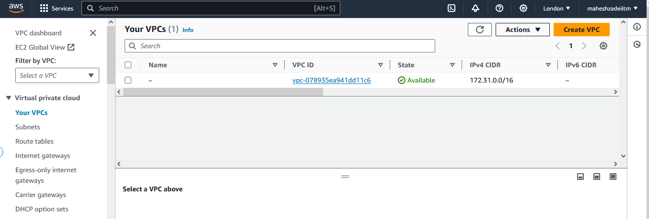

Give the Name Tag : mahesh-vpc-xyz-09.04.2024

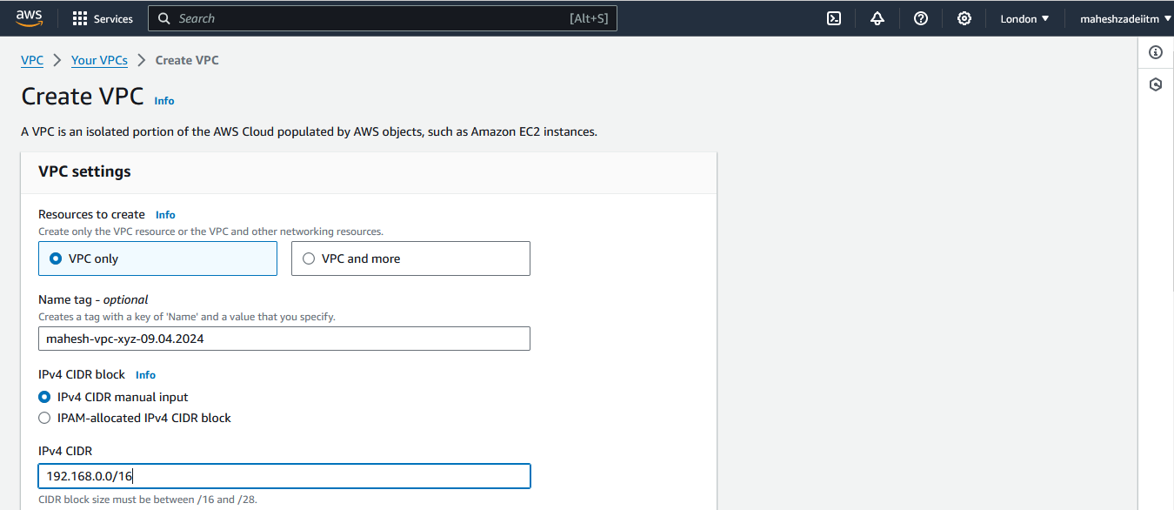

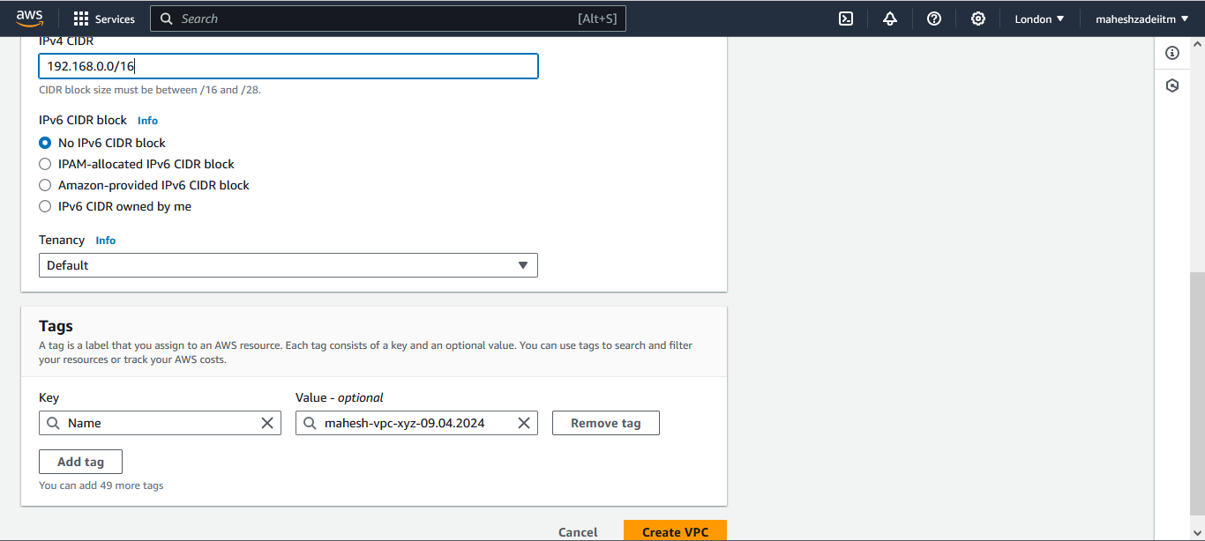

Click Create VPC

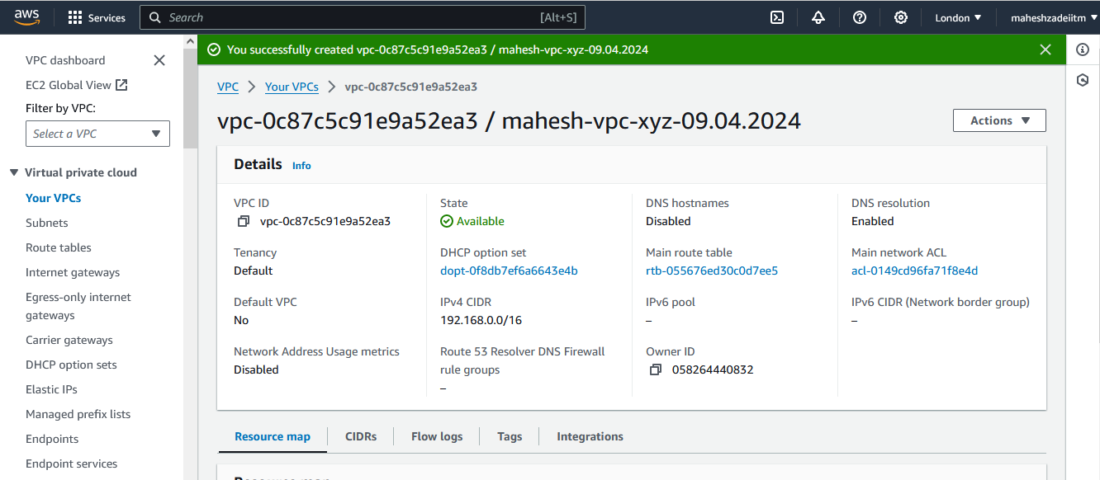

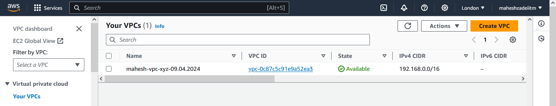

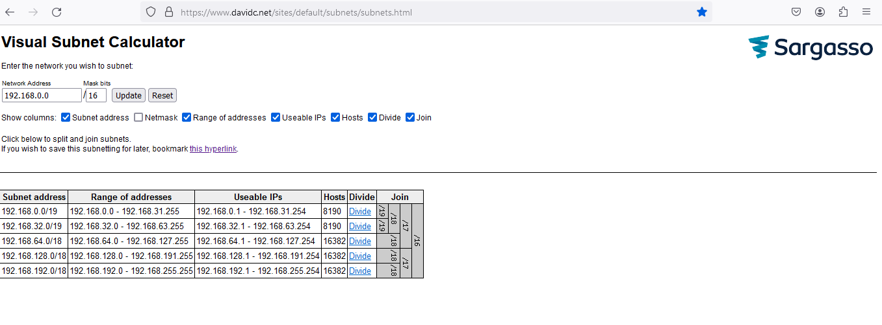

Select the CIDR Range 192.168.0.0/16

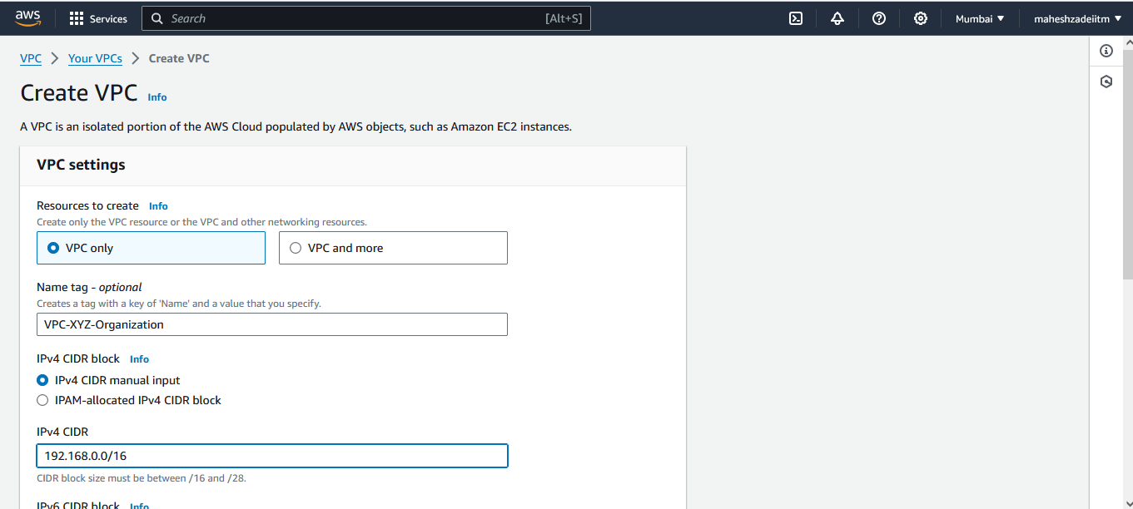

Click on Create VPC

VPC Created

Go to subnet

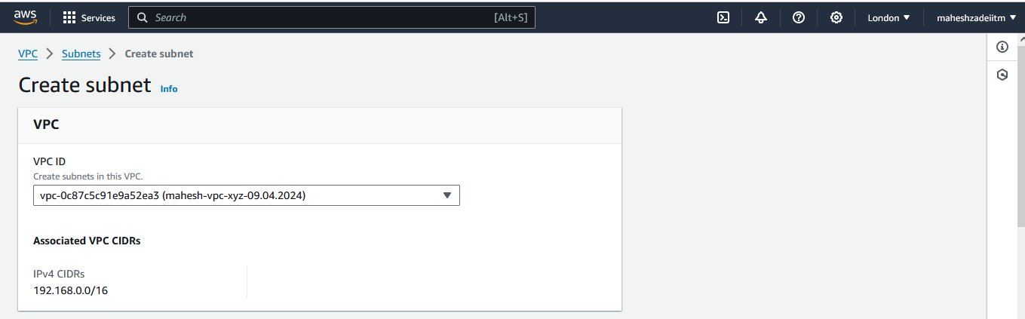

Crate the Public subnet as

**Web Tier (Public)**

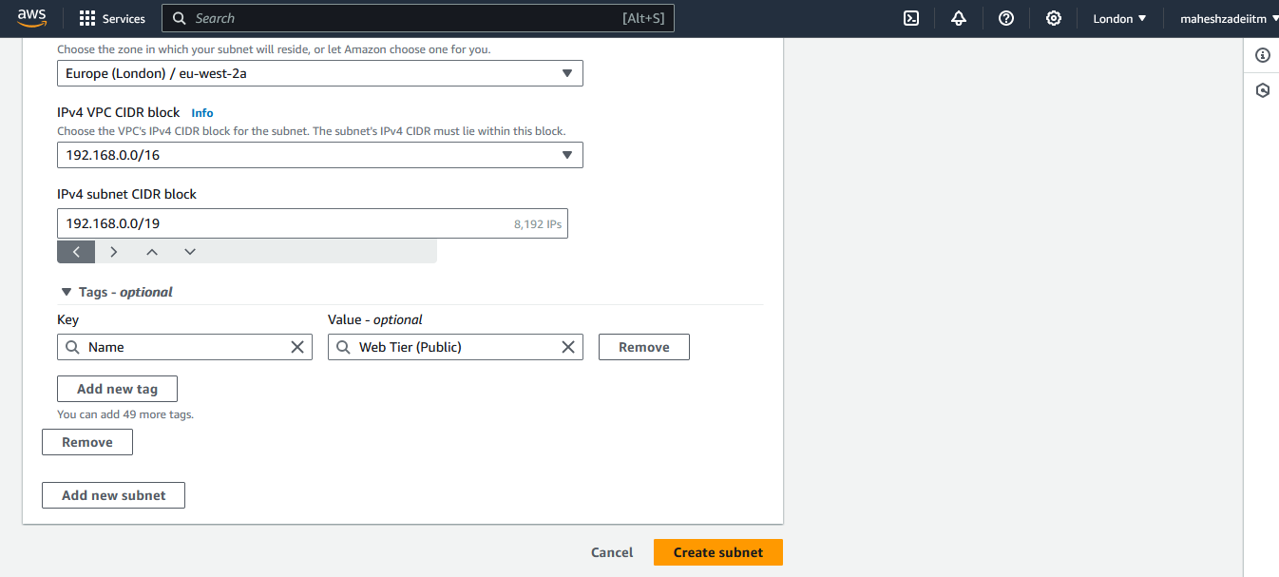

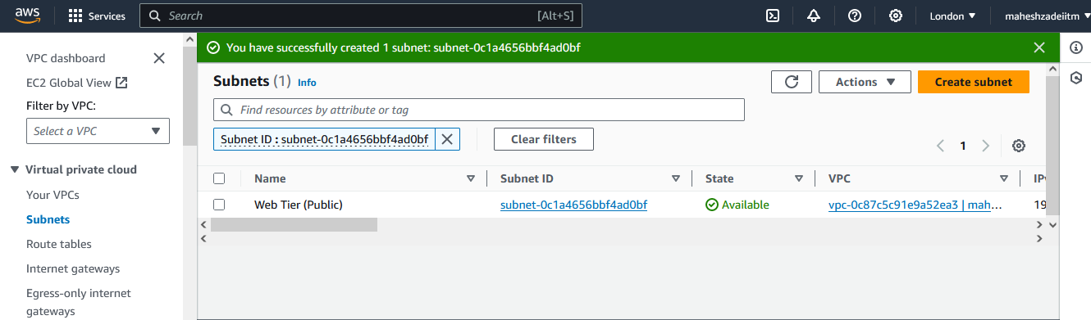

**One more EC2-win-public install in web subnet to connect private subnet EC2 Instances**

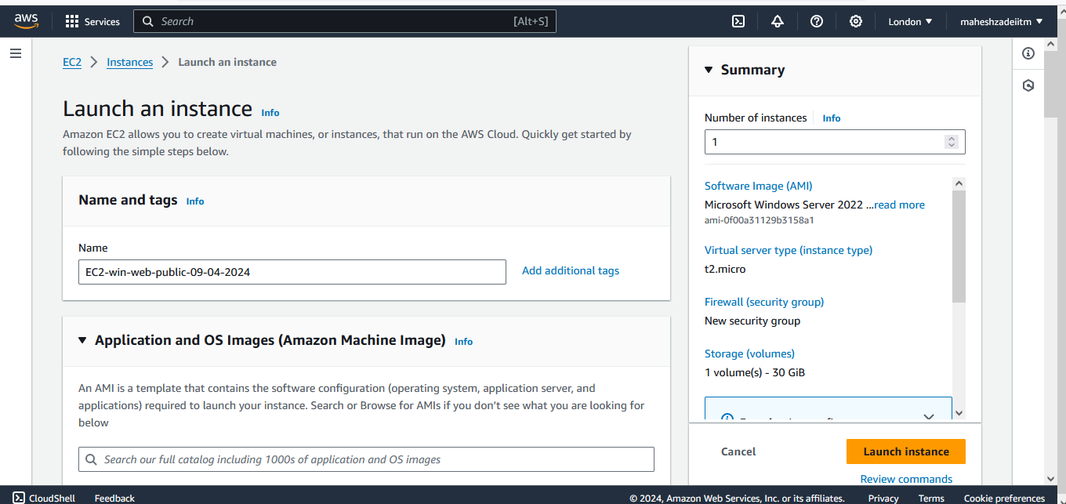

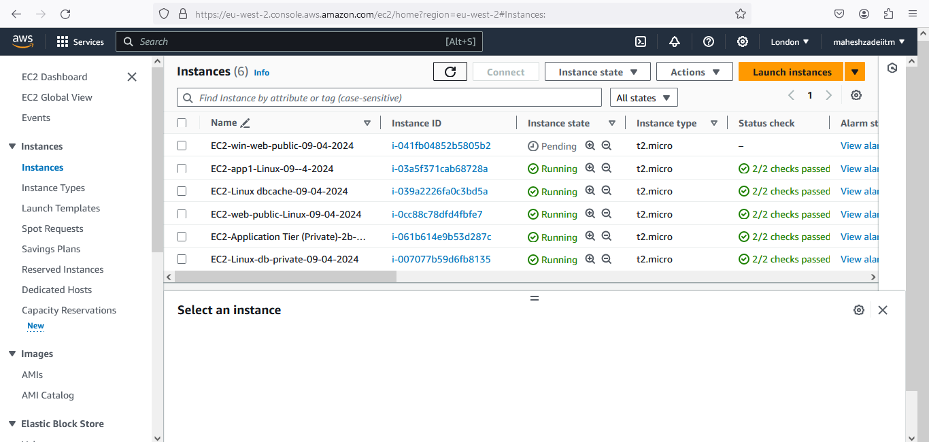

**Ec2-win Launched to connect a private subnet instance**

**Copy londonkey pair and Mobaxterm in EC2-win machine**

**Copy private IP of Ec2 Instance in private subnet**

**Paste in mobaxterm , type user name as ec2-user and browse the private key from London DC.**

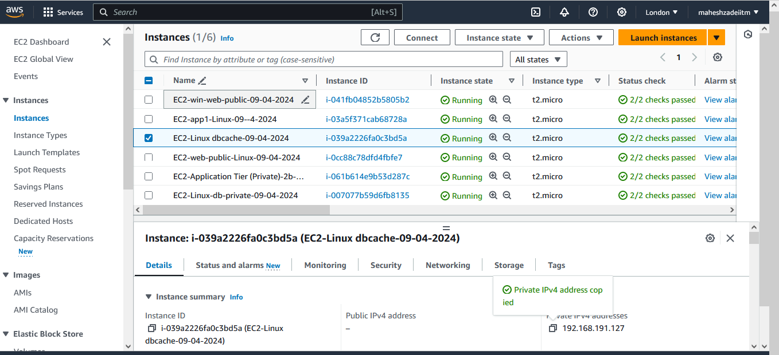

**Now click on OK**

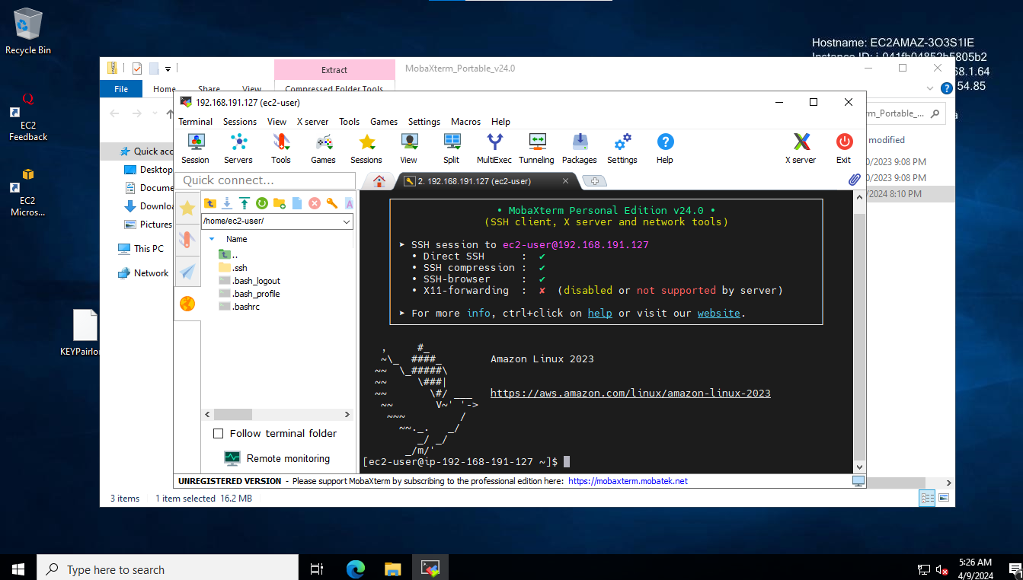

**Private subnet instance is connected from web Public Subnet**

**One more we will connect**

**Successfully connected the private subnet instane from Web public Subnet**

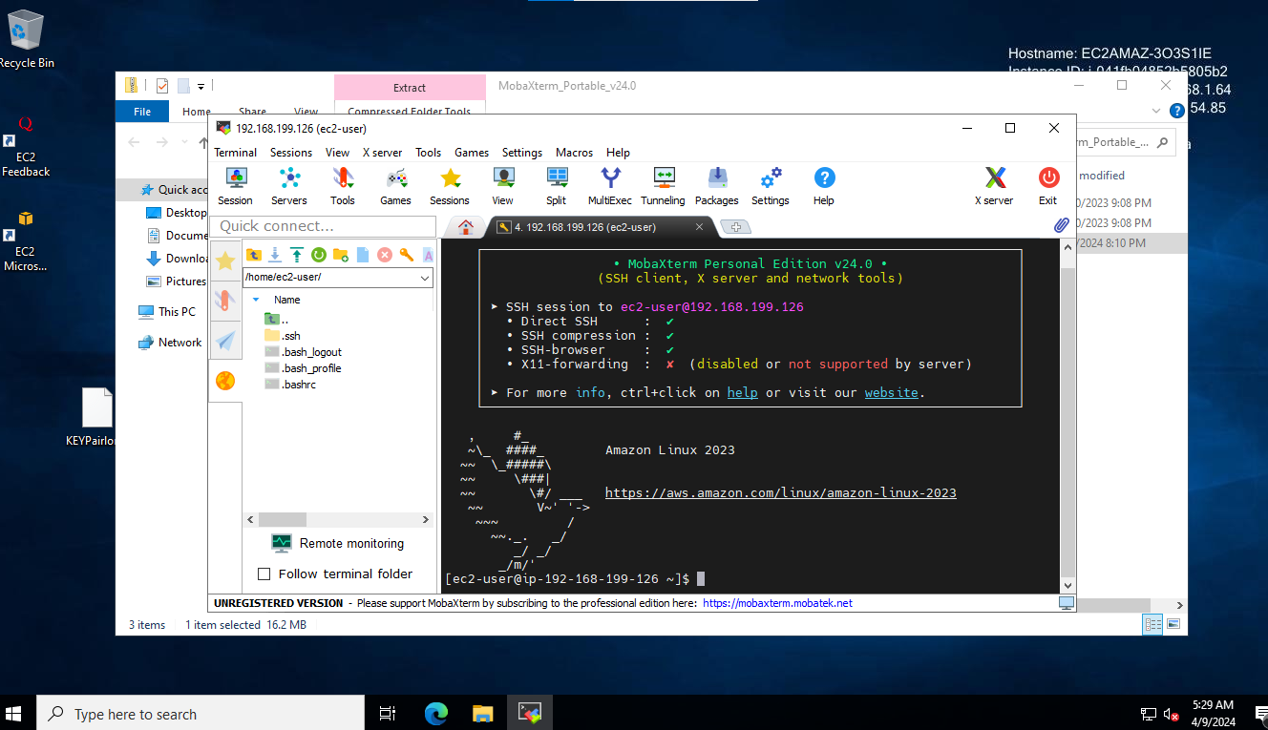

**Now click on add new subnet as Application Tier (Private)-2b**

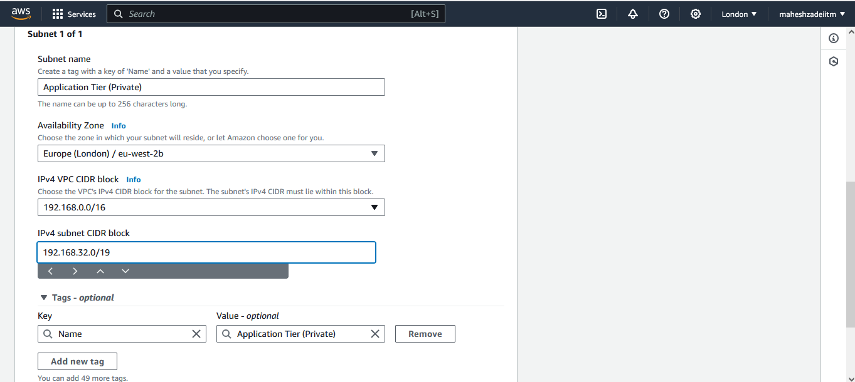

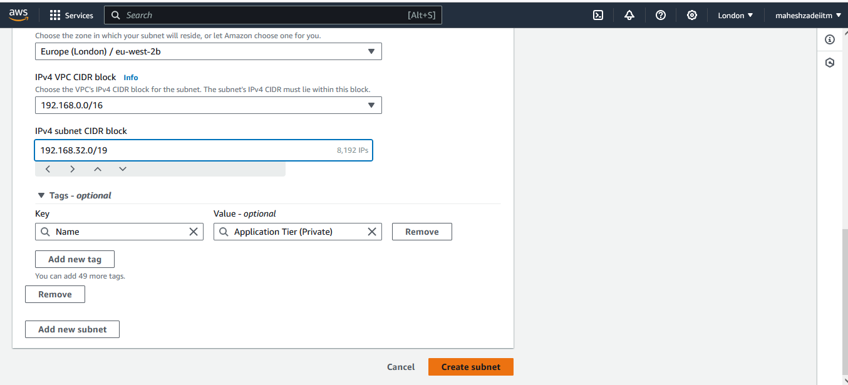

**Create the Third private subnet as Application Tier (Private)-2c below**

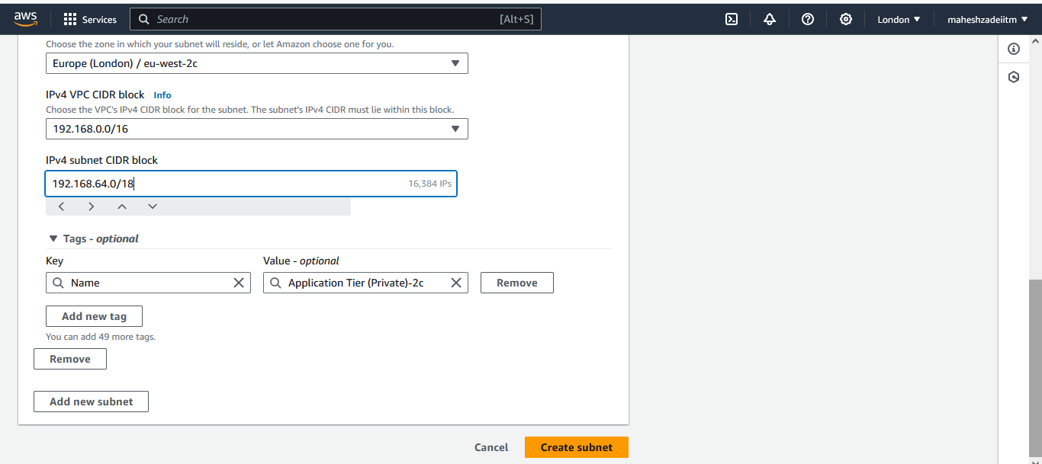

**Create 4rth subnet private subnet as below**

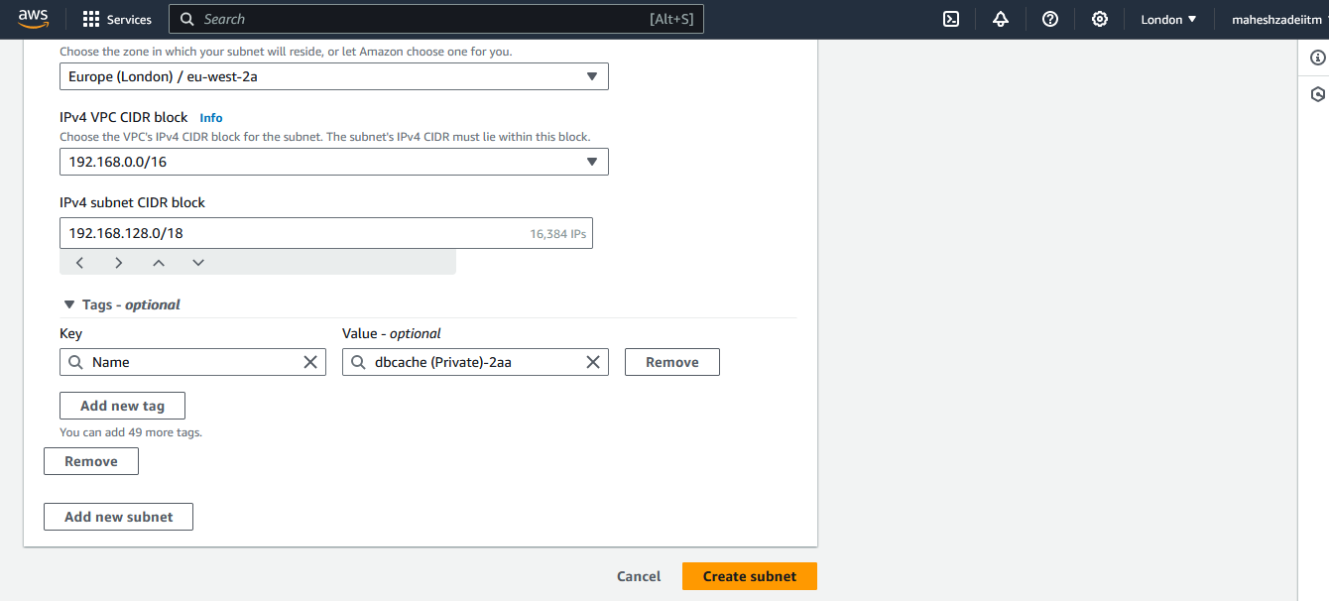

**Create the 5th subnet as below**

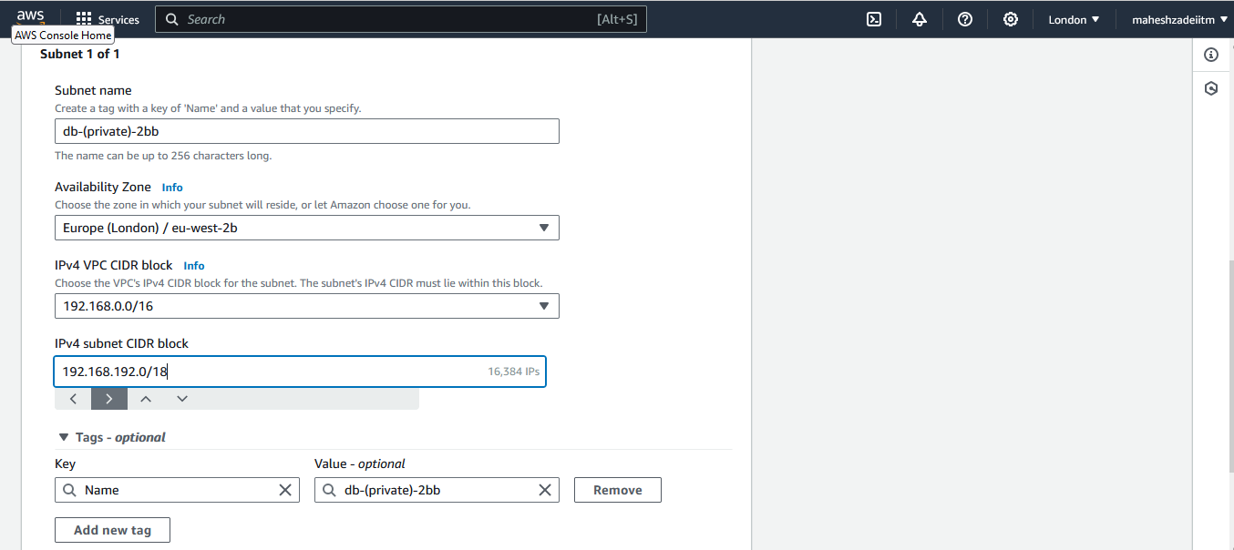

**Now Click on create subnet**

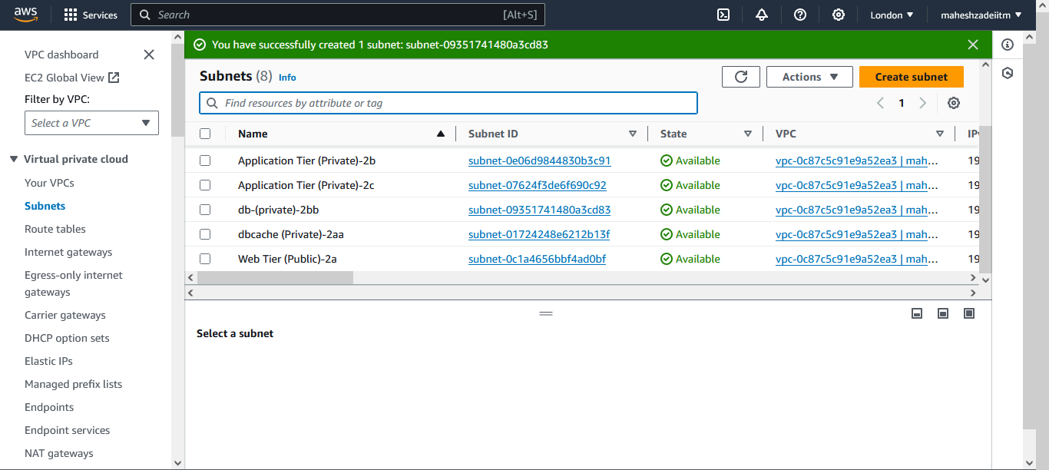

**Above All 5 subnets are created**

By default all the subnets are private , we have to make the Subnet Public by adding internet gateway

Now go to internet gateway and attach it to public subnet

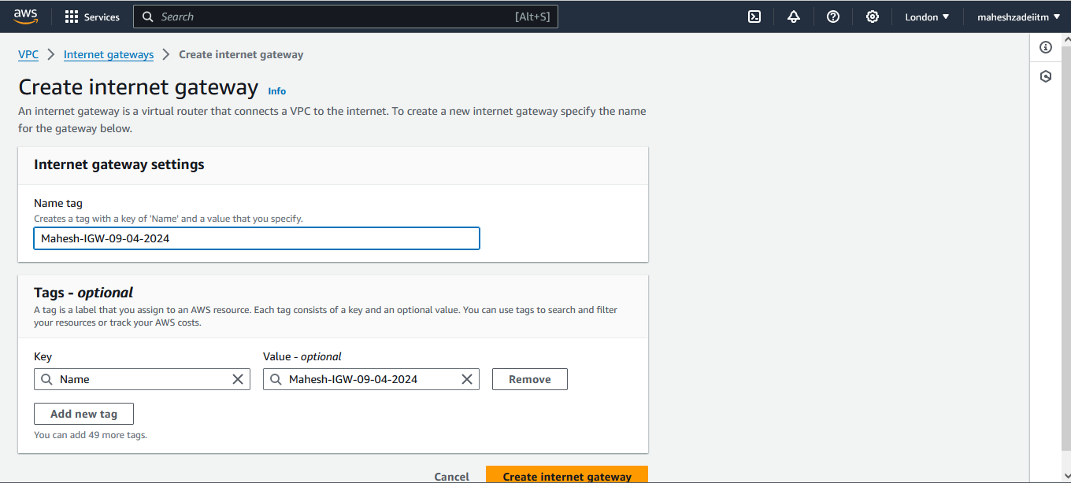

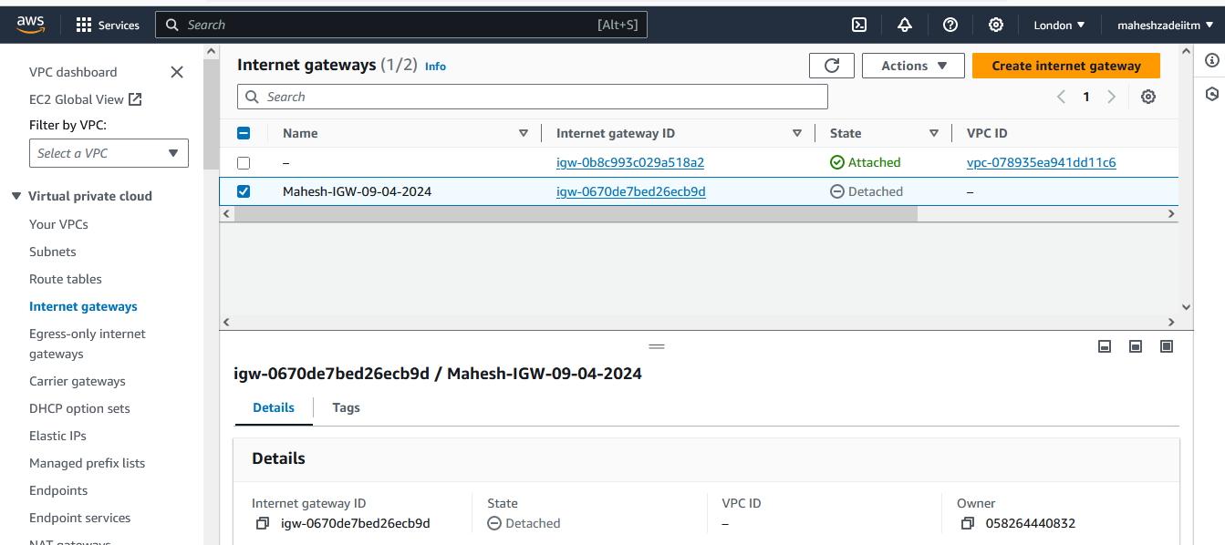

Internet Gateway created

Attach IGW to VPC

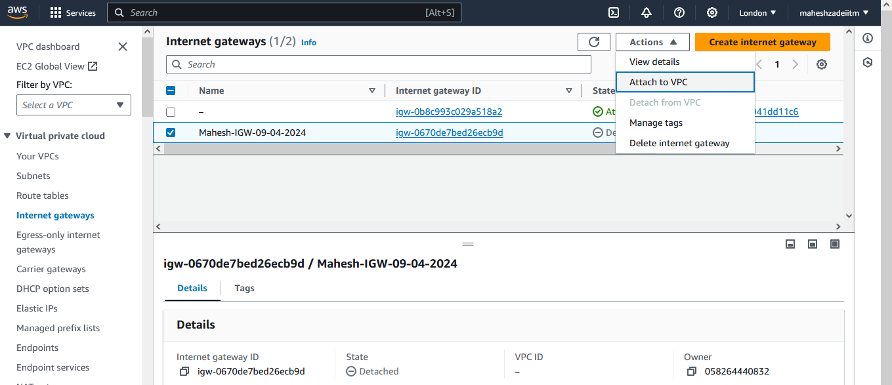

VPC Attached

Now create the Route Table to access the subnet Why to create a 1 or 3 RT

Reason : There is no way to attached the internet gateway in subnets.

Route Table was created to get internet access to subnets.

Now Go to Route Table and create

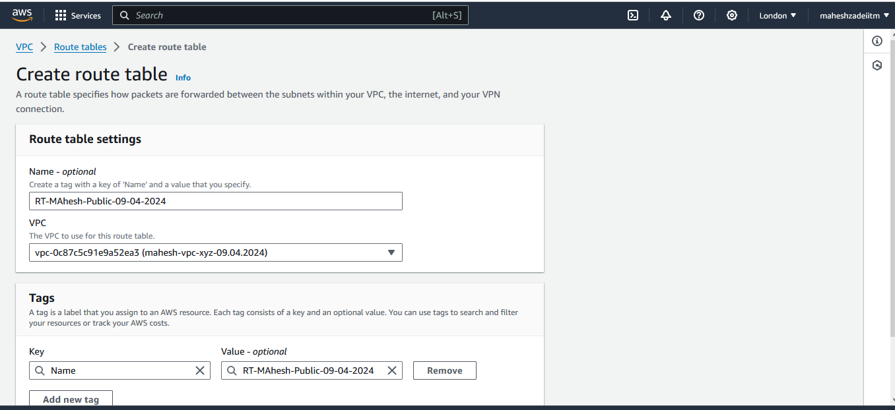

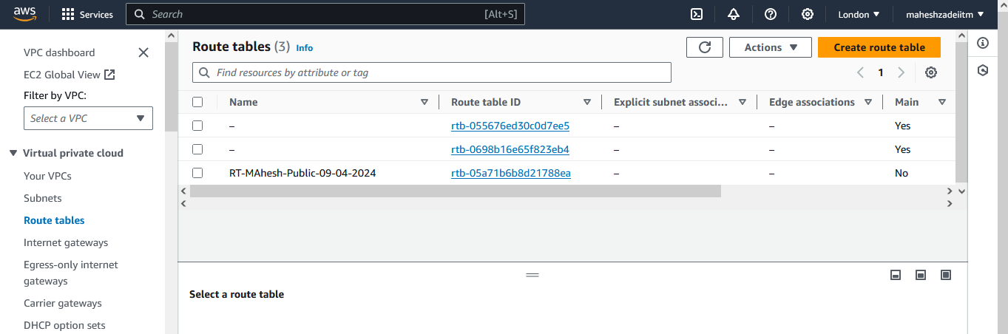

Click on subnet association.

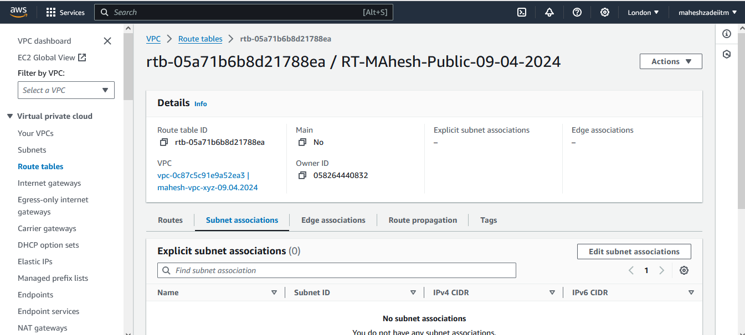

Edit subnet association and then save association

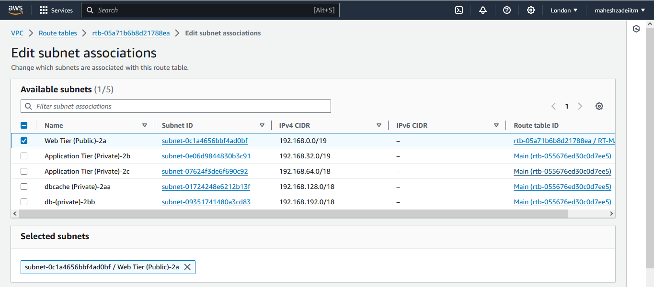

Select public subnet and save association.

Now go to route and edit rout and make the web subnet as public

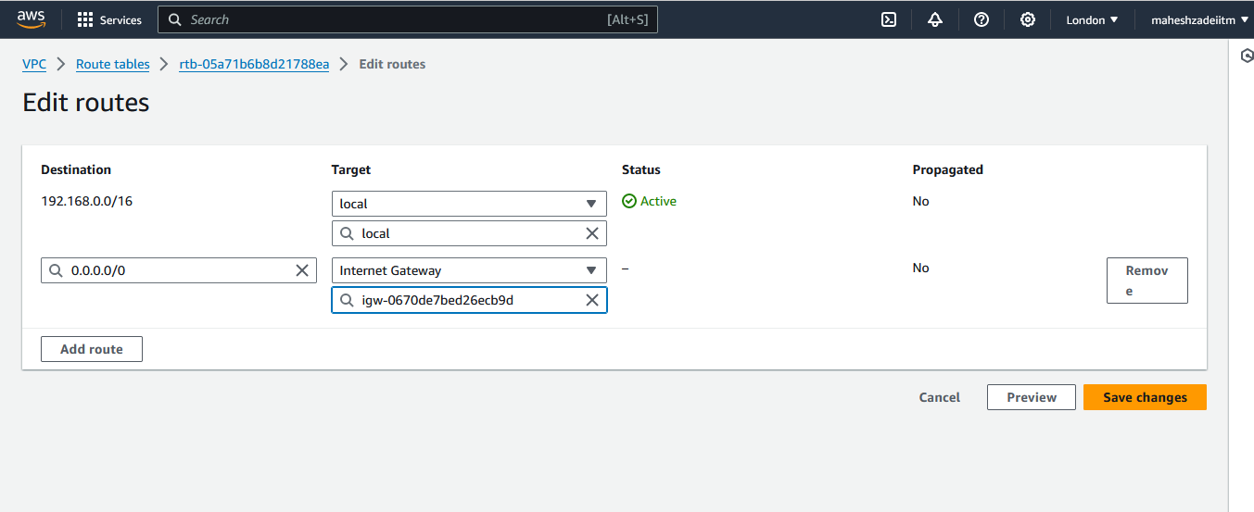

Go to Public subnet and enable public IP .

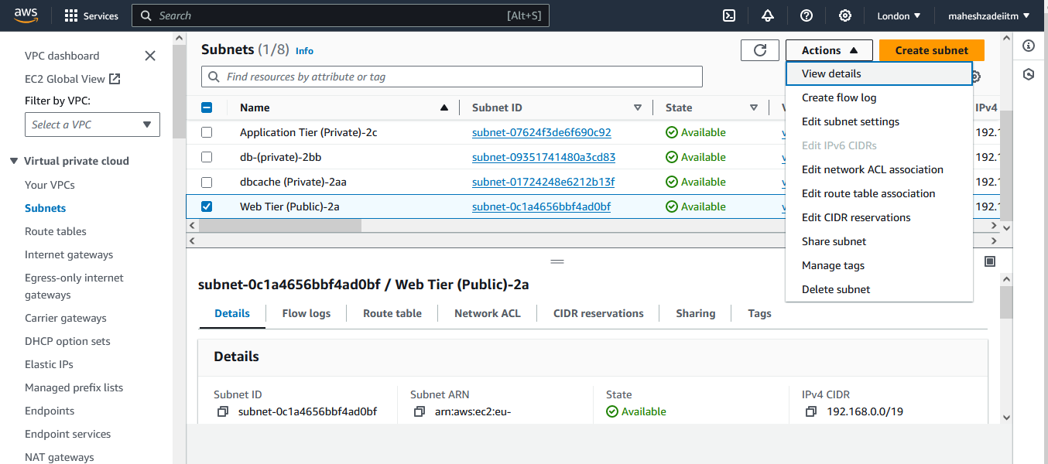

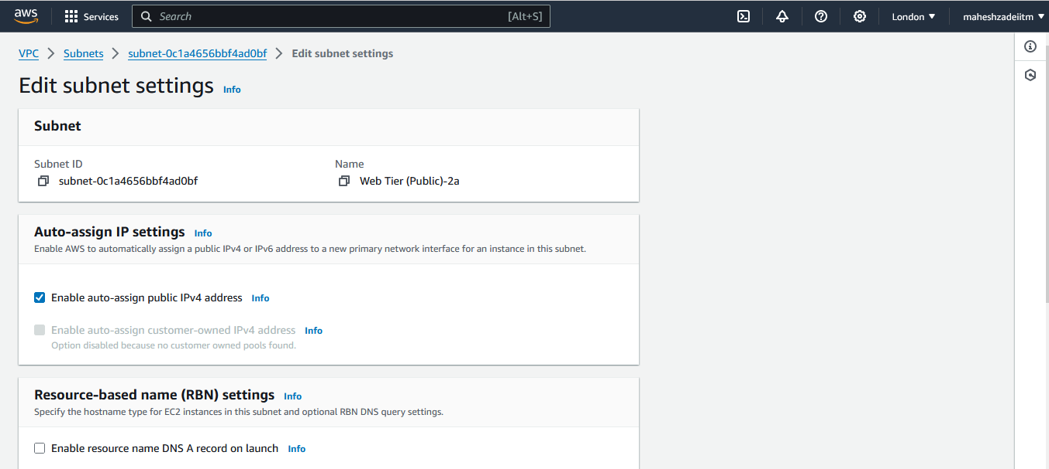

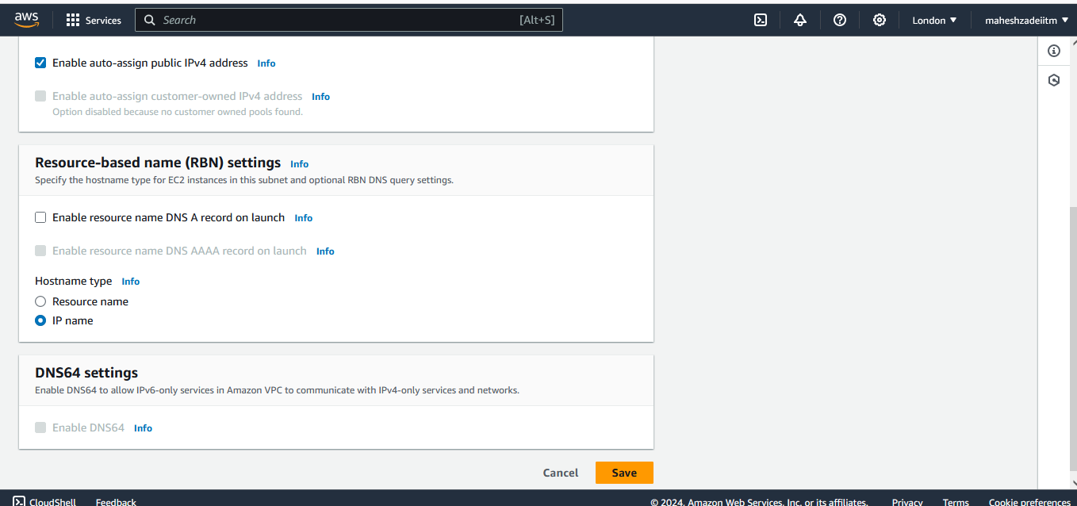

Now Go to EC2 Instance and Launch web public instance .

Go to Settings , edit setting and choos the Custom VPC and Public Subnet

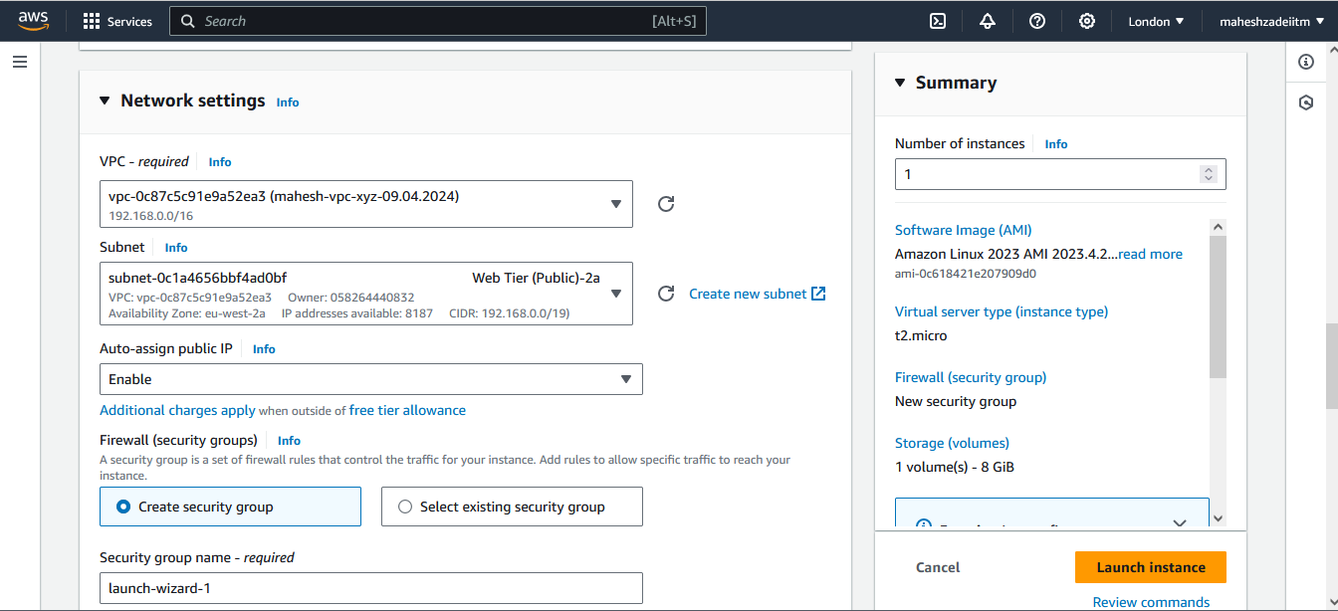

Security group create new

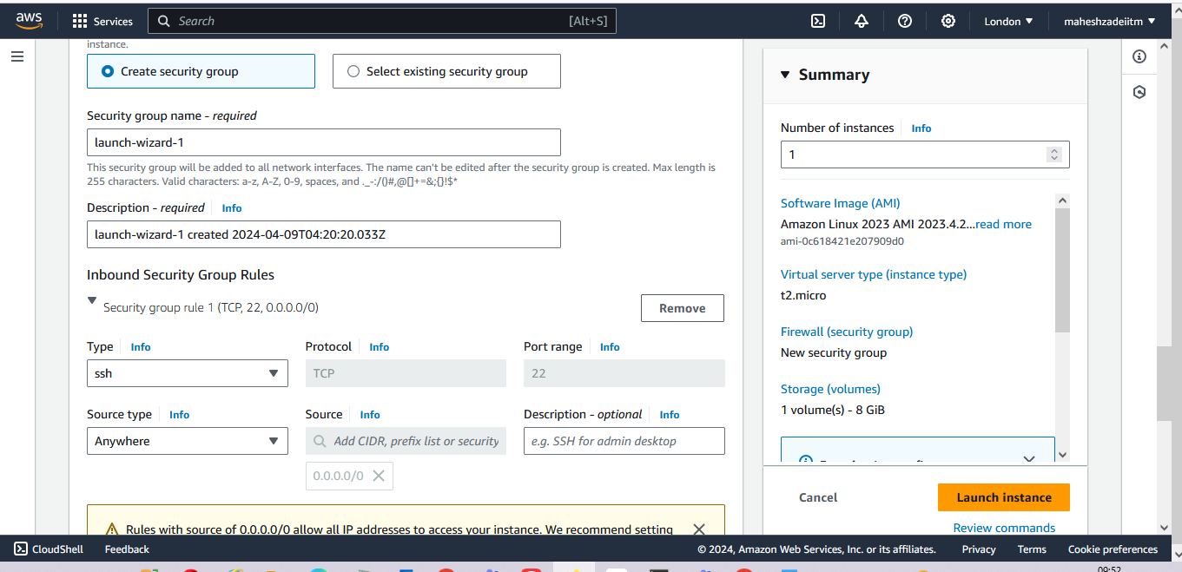

EC2 Instance launched in Web subnet 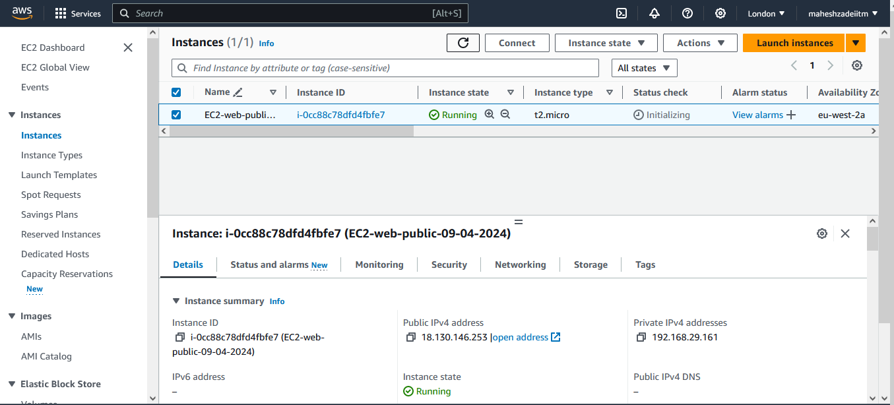

Copy Public IP and paste in Mobaxterm to connect EC2 Instacne in Public web Subnet

Now Click on OK

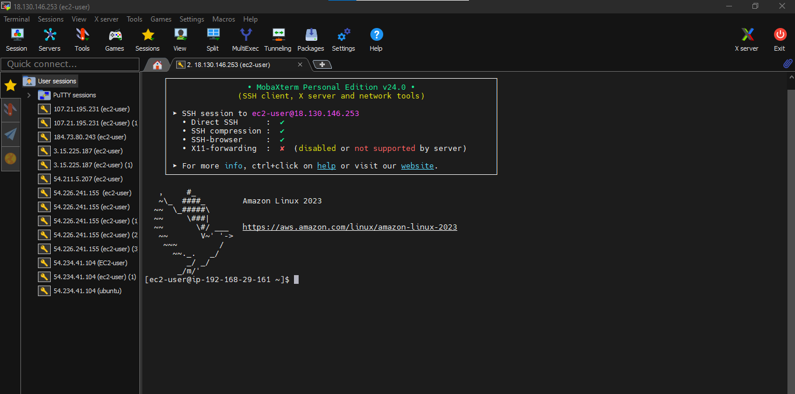

Ec2 Instance Connect in web Public Subnet and Successful

Launch EC2 instances in each subnet and name them according to their subnet

Web-done,

Lauch EC2-Linux in app1 Subnet

Now launch EC2-Linux dbcache private subnet db). 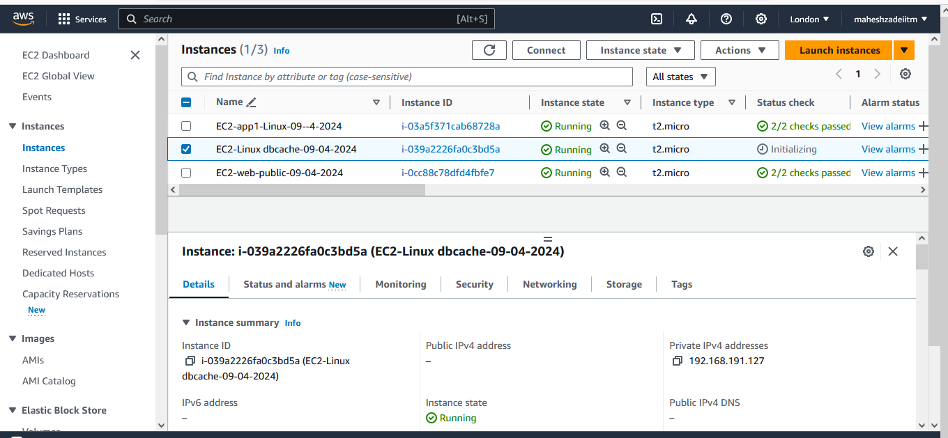

EC2 Launch in Application subnet

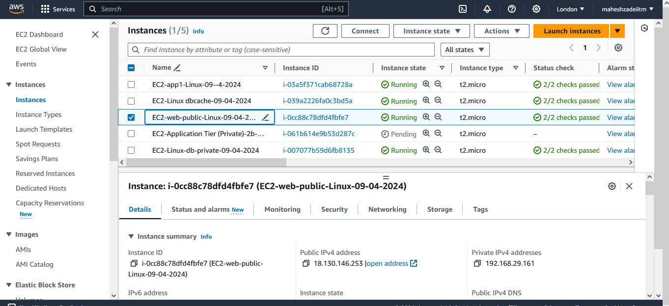

All 5 EC2 Instances are Launched .

Allow dbcache instance and app1 subnet to send internet requests.

Mean Enable Internet to AWS EC2 hosted on Private Subnet via NATgateway.

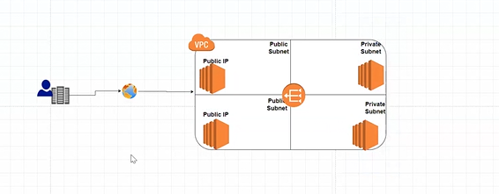

NAT GATEWAY will give the internet to private subnet

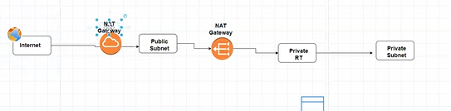

Internet can access the private subnet but private subnet can not access the Internet dute to NAT Gateway.

Internet gateway is free

NAT gateway is Chargeable =0.004 USD/per hrs

Internet gateway is two want and Nat gateway in one way.

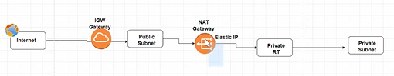

Elastic IP is there we have to pay to AWS .

>>> When you create a NAT GW one EIP will be created Automatically that is the reason for NAT GW is chargeable

>>> When you delete your NAT GW, EIP is not automatically Deleting, you have to delete it Manually ????

Go to the NAT >>> Create NAT gateway

Give your NAT GW Name

Choose your Any Public Subnet

Connectivity type >>> Public

Allocate EIP

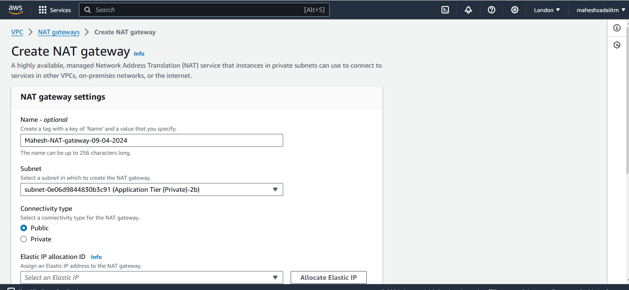

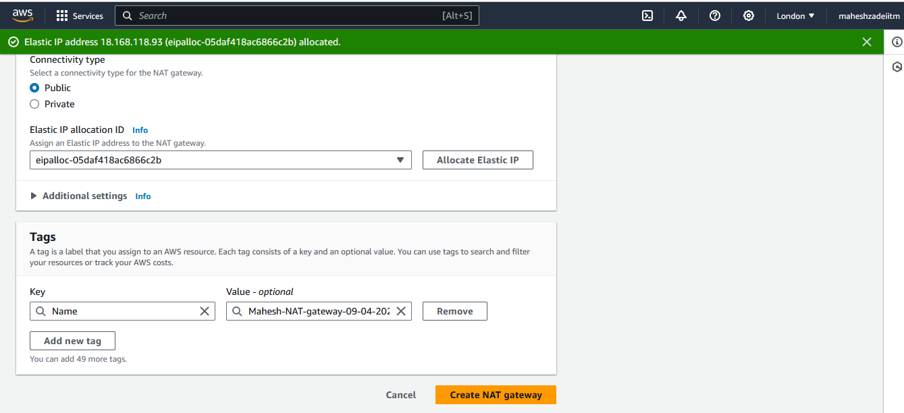

Create NAT gateway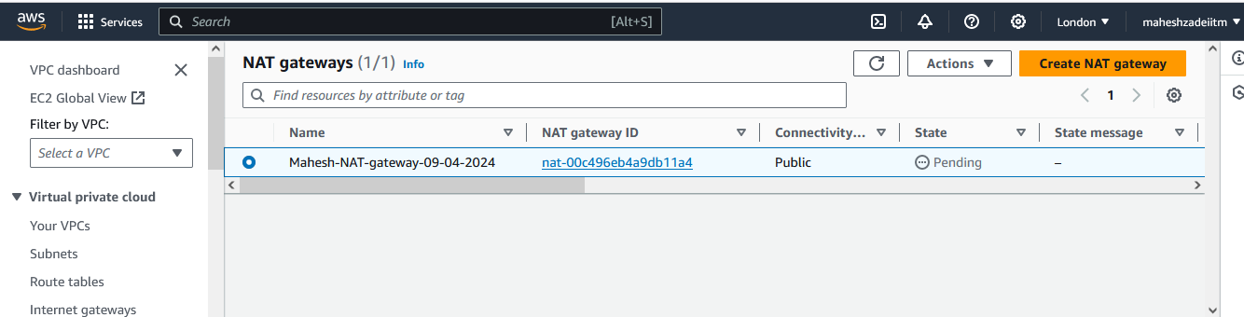

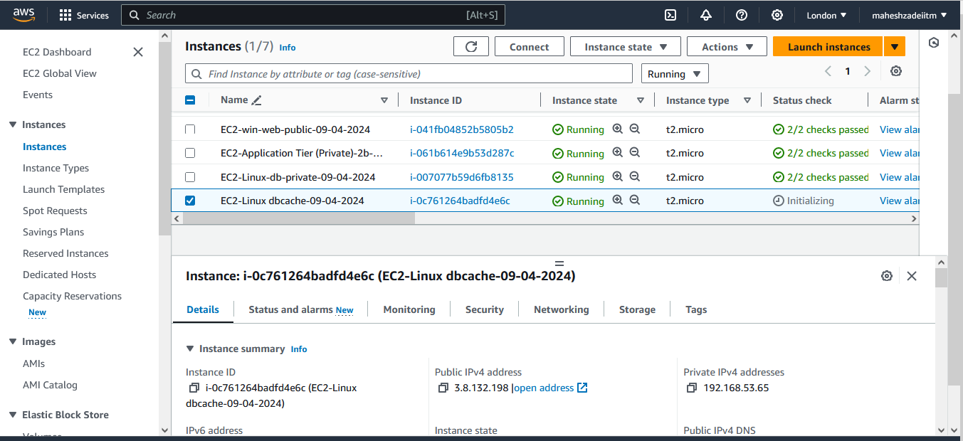

Allowed dbcache instance and app1 subnet to send internet requests via NAT Gateway

Checked by Mobaxterm

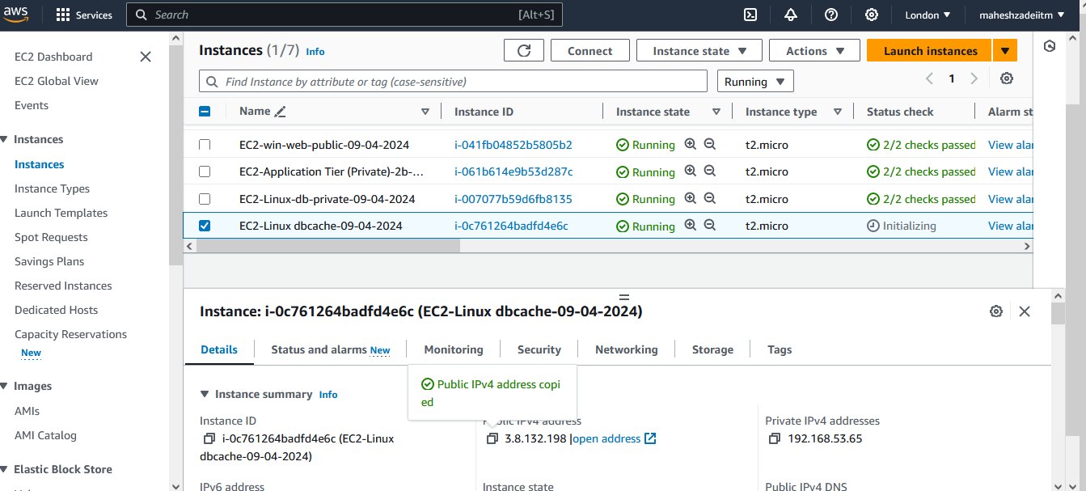

Copy public IP of dbashe Ec2 Machine and Type user name as ec2-user and upload the London keypair

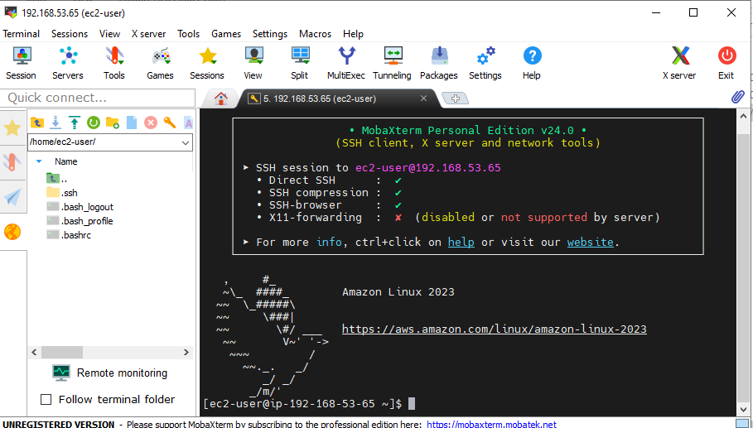

Now Click on OK

Manage security groups and NACLs.

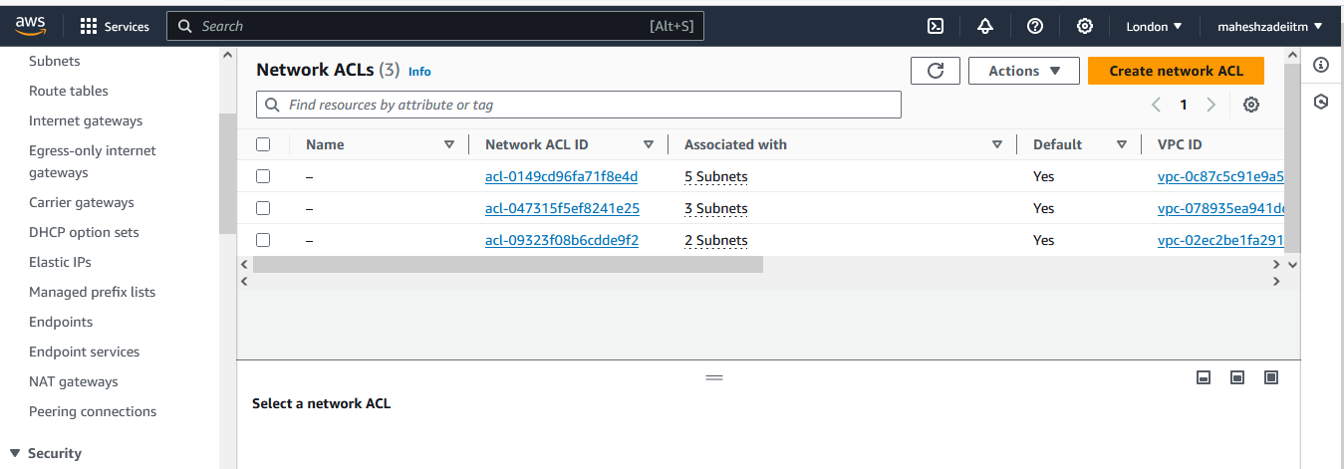

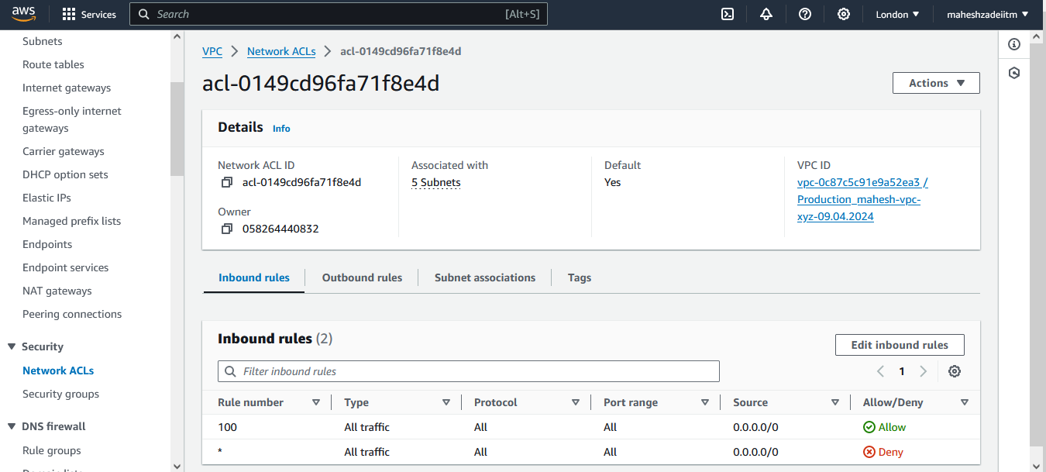

Security groups Created

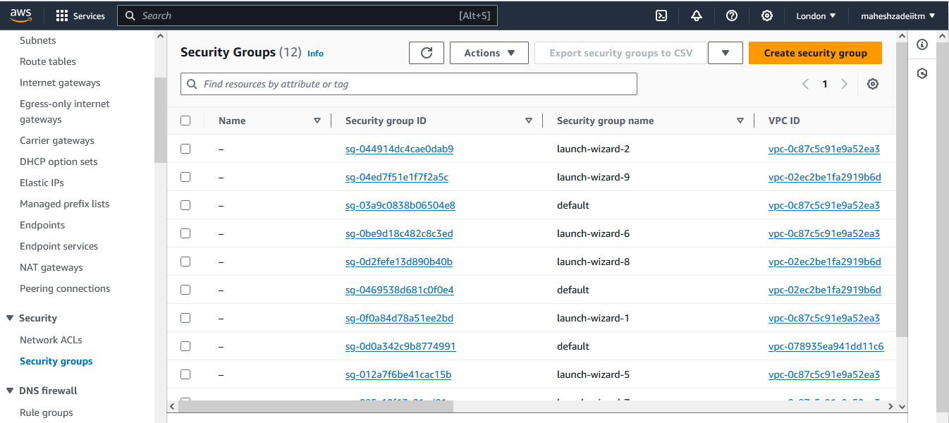

**Development Network:**

1. Design and build 2-tier architecture with two subnets named web and db

and launch instances in both subnets and name them as per the subnet

names.

2. Make sure only the web subnet can send internet requests.

3. Create peering connection between production network and development

network.

4. Setup connection between db subnets of both production network and

development network respectively.

Create production VPC

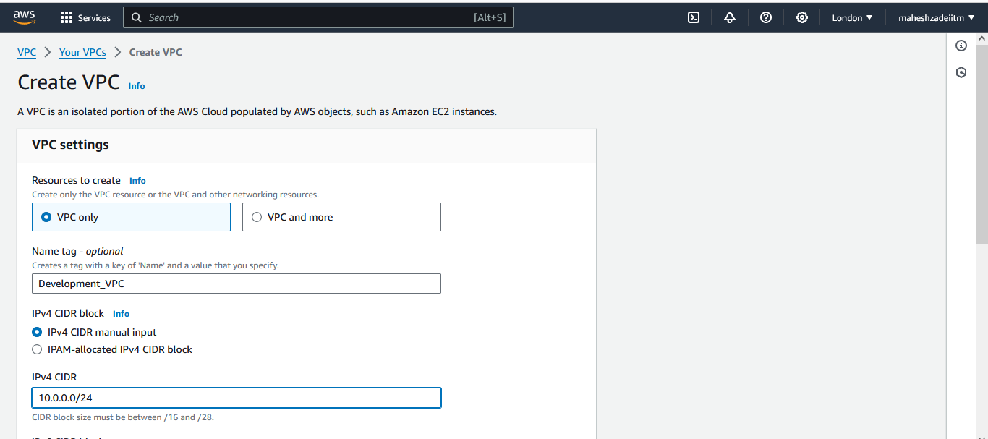

CIDR : 10.0.0.0/24

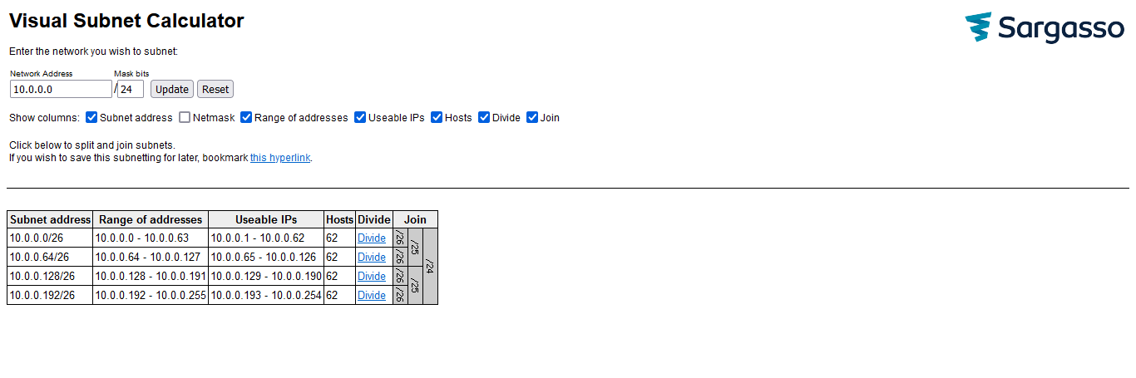

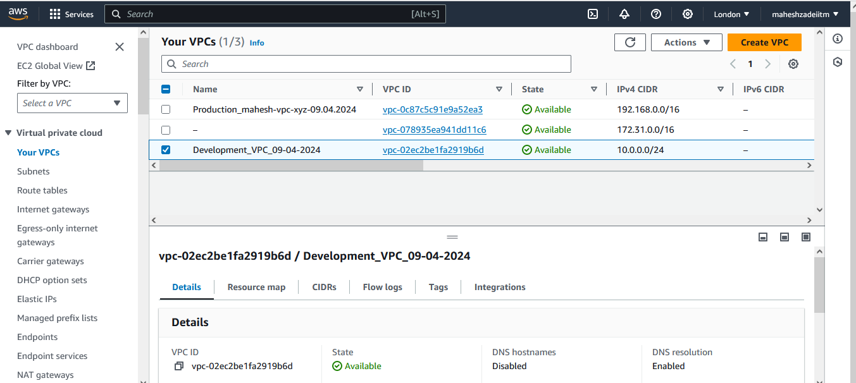

Now go to create the subnet

Click on create subnet

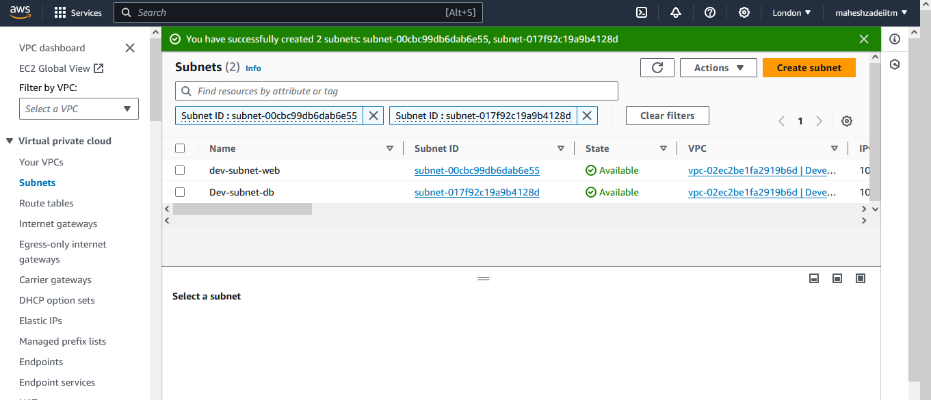

Create Internet gateway

Attach it to VPC

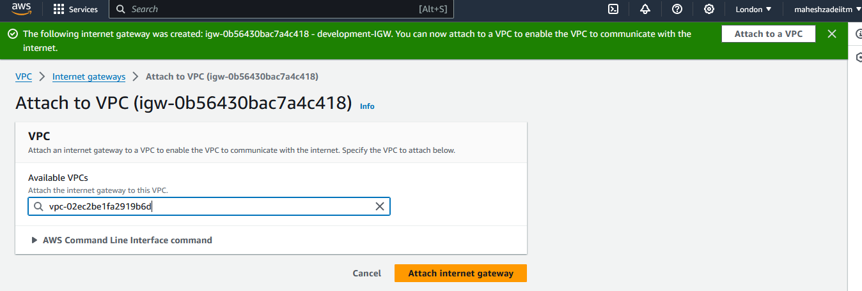

VPC Created

Now Create Route Table

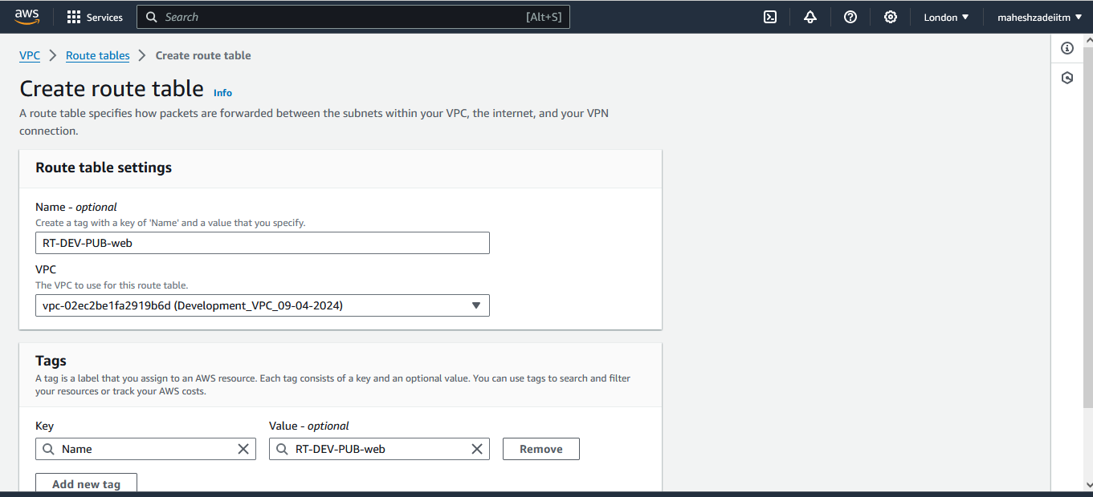

Click on Create RT

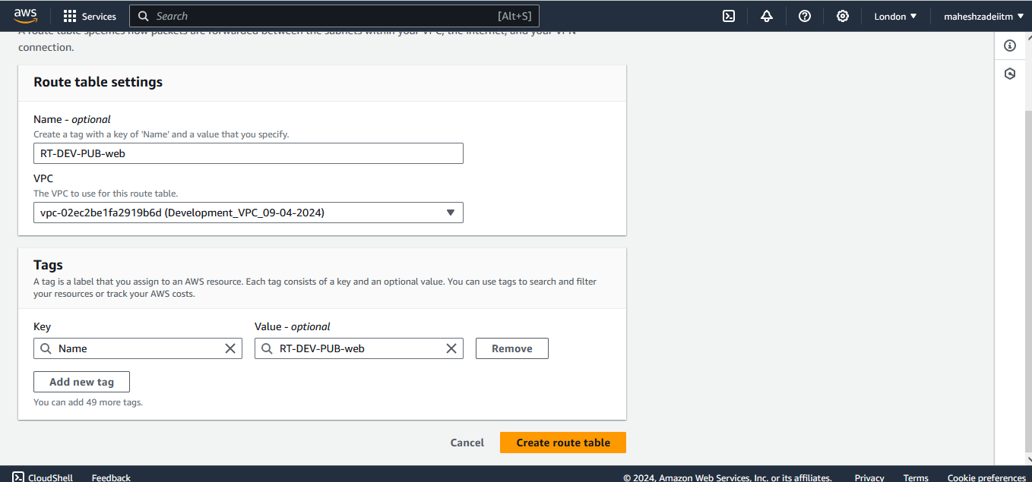

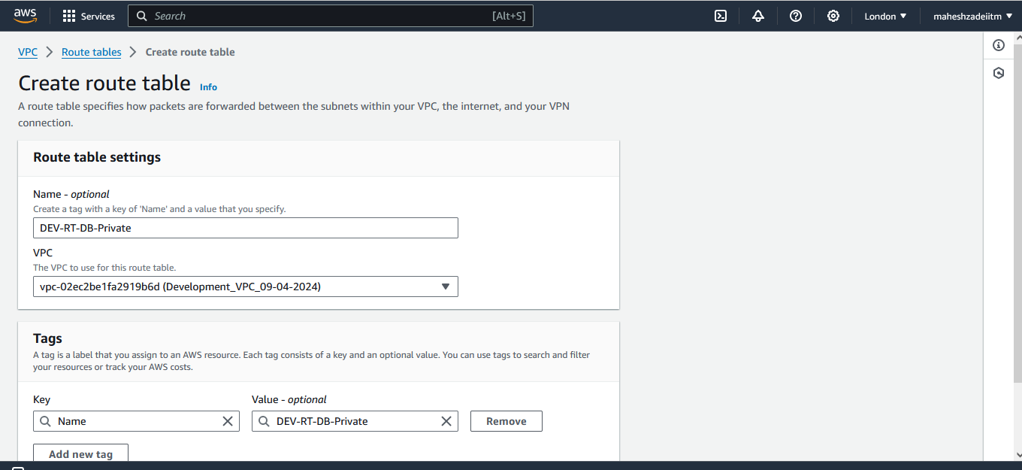

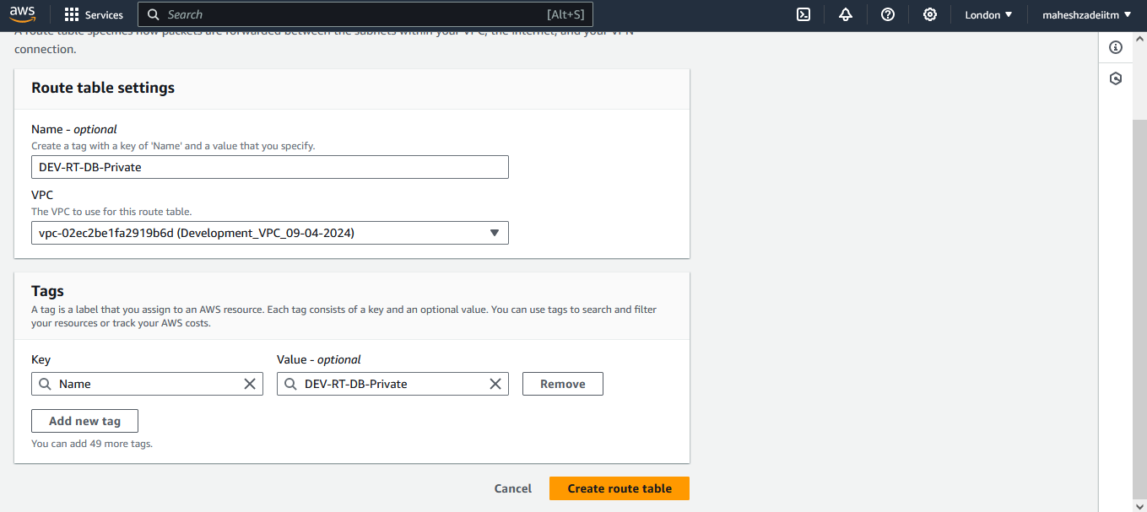

Now make the web RT Public

Go to Route Table

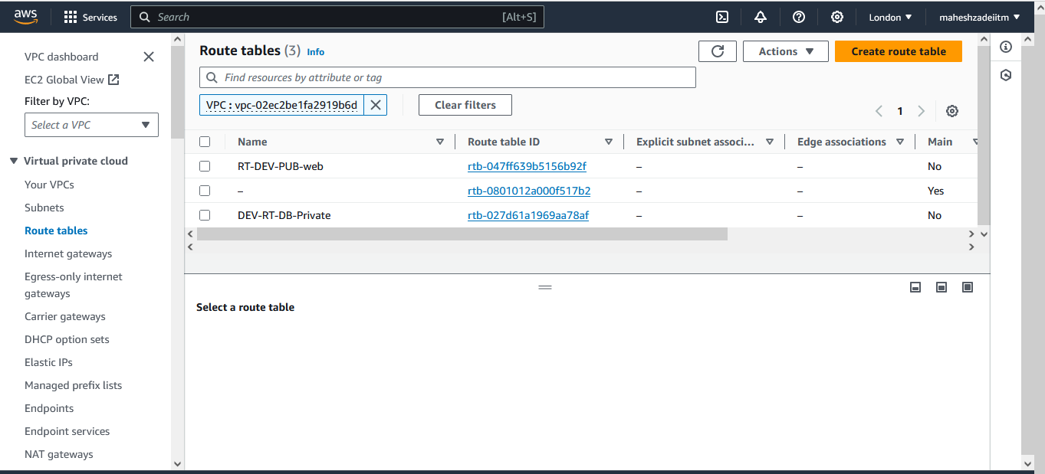

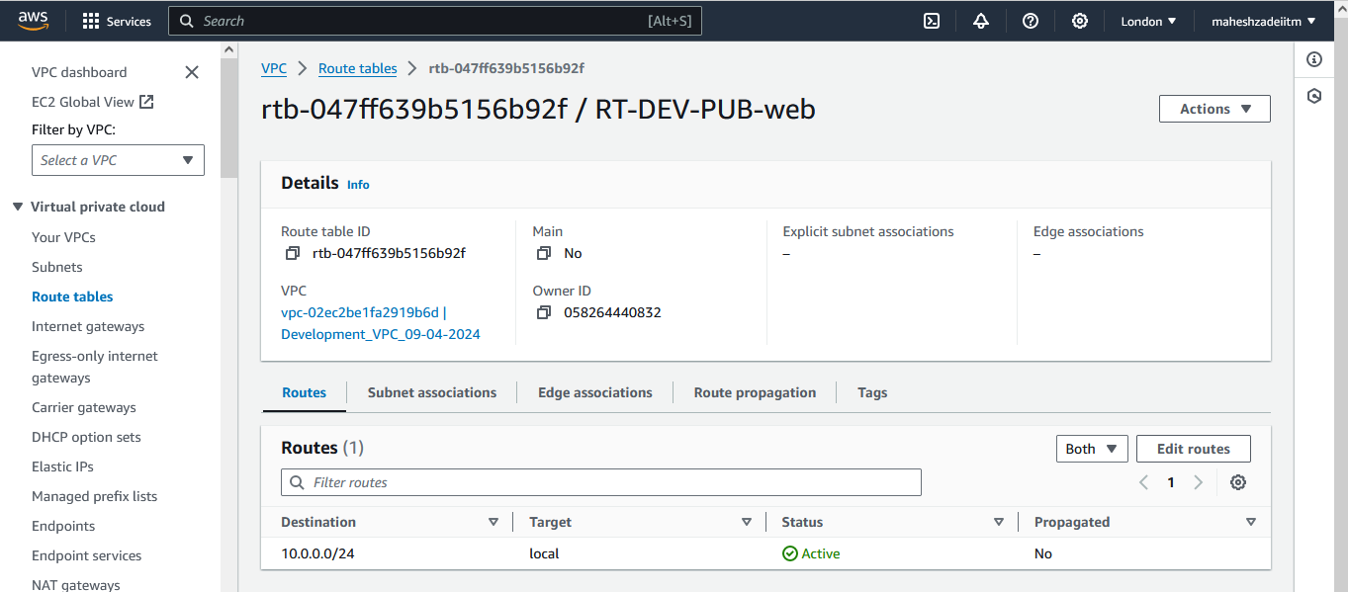

Click on subnet association

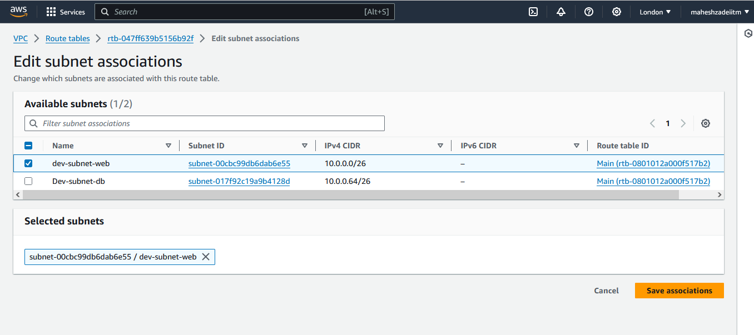

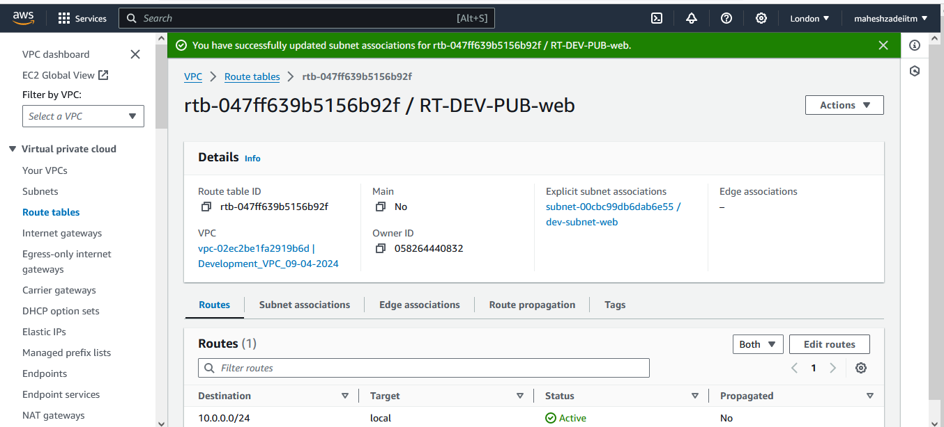

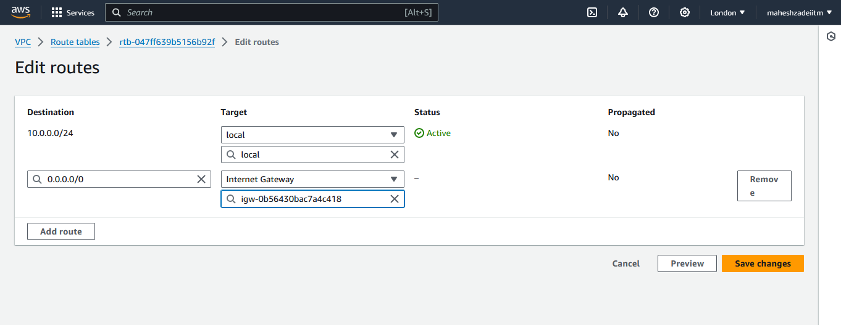

Save Changes

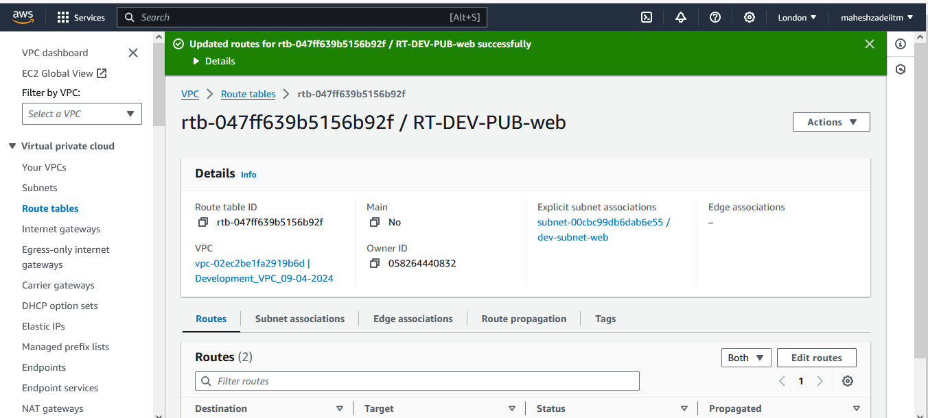

Now Create the EC2 Instances in both the subnets win and Linux respectively

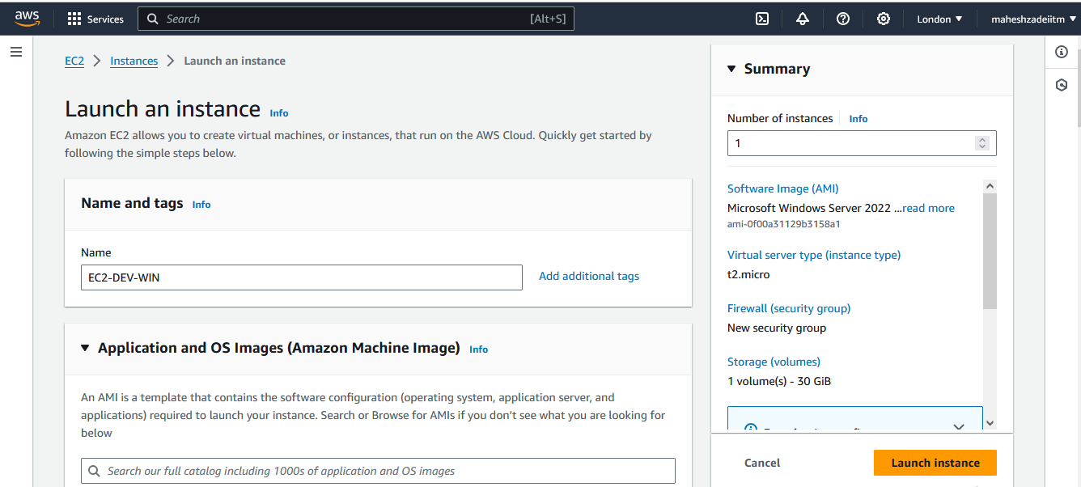

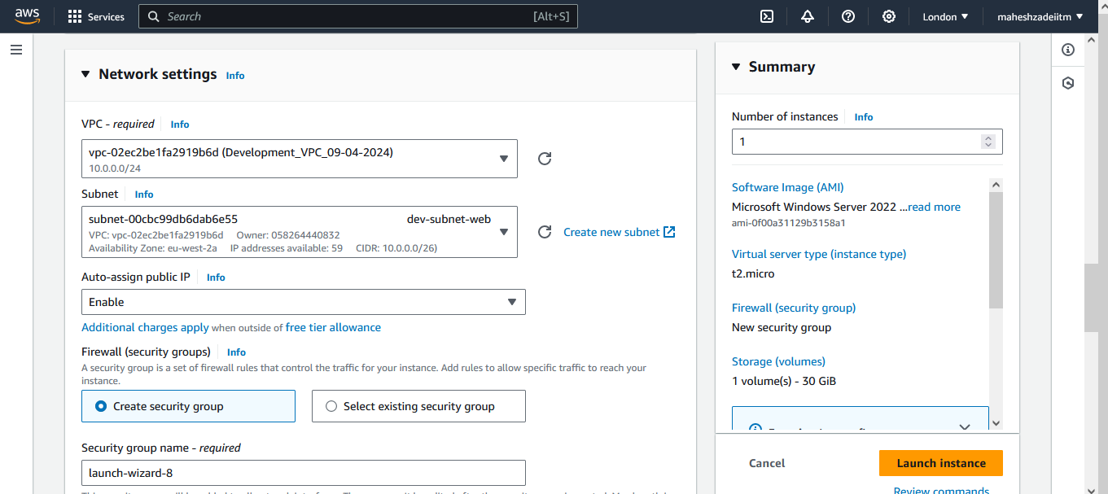

EC2 Win Launched and connected

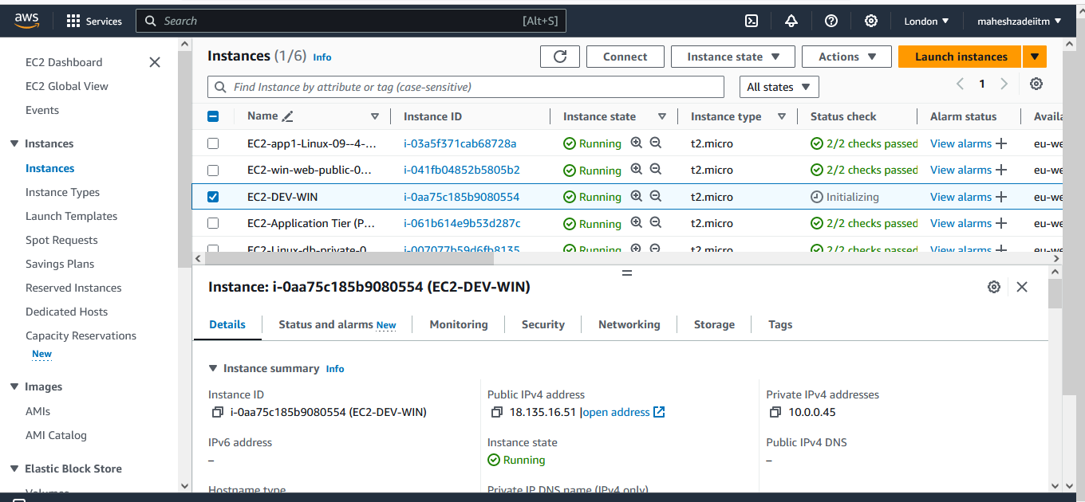

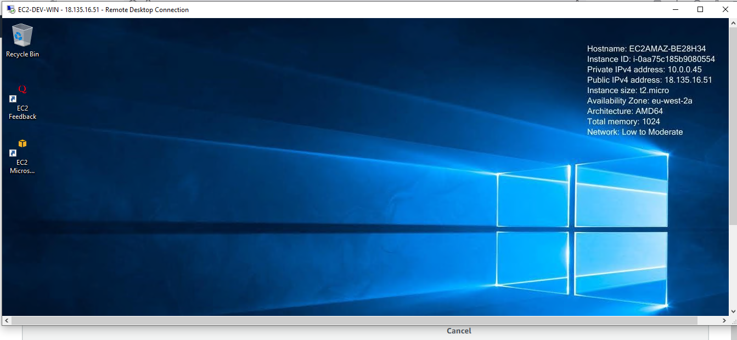

Copy the London Keypair and Mobaxterm in win Ec2 Machnie to connect Linux EC2 Machine .

Now launch EC2- Linux in DB Subnet of Development

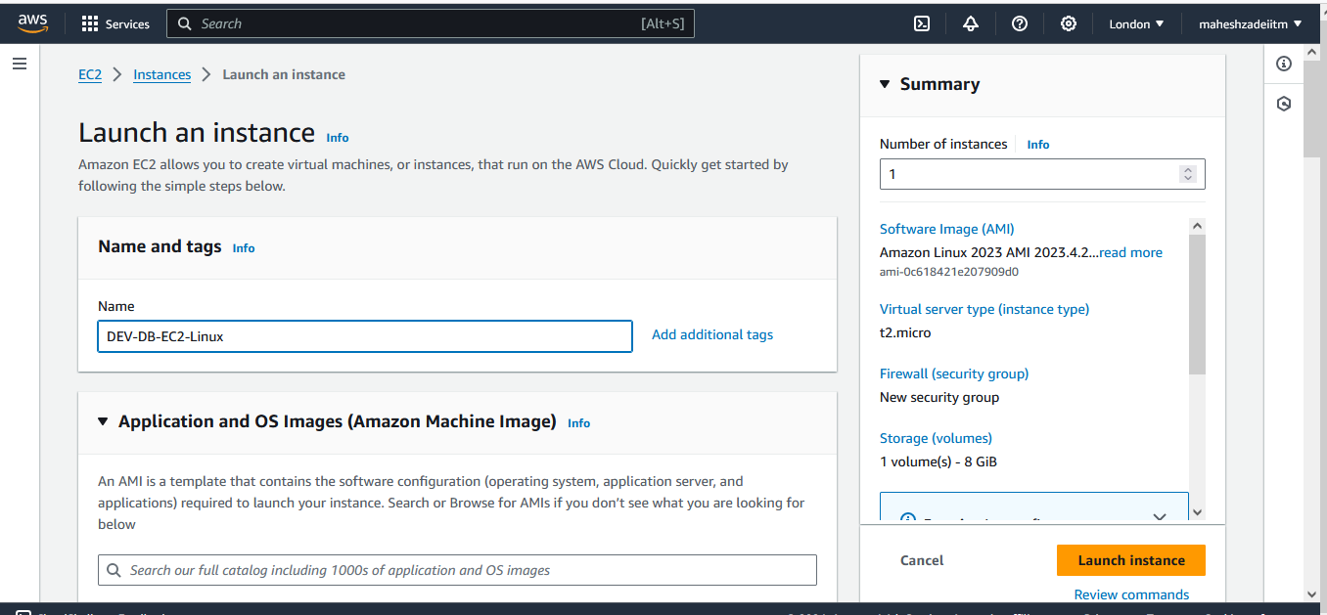

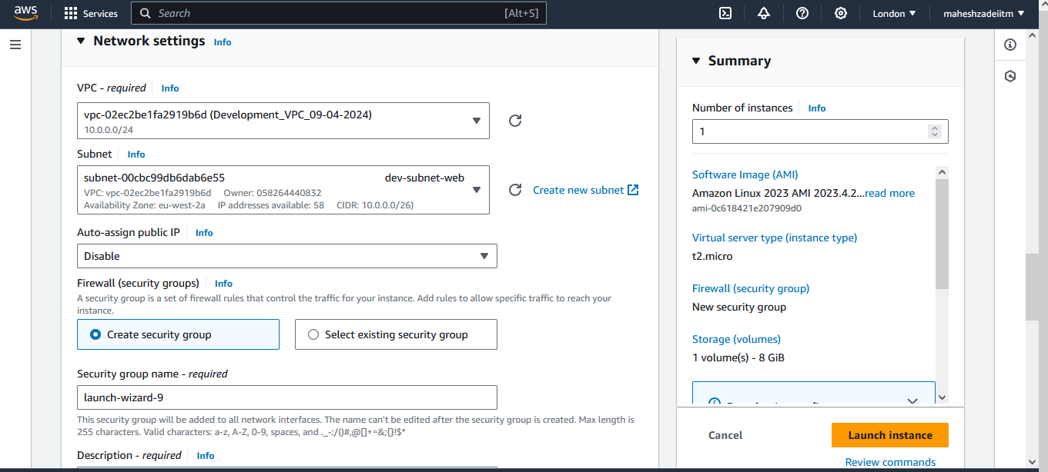

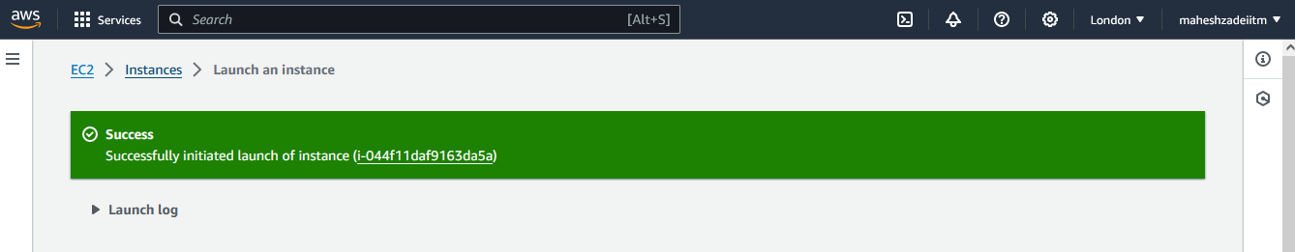

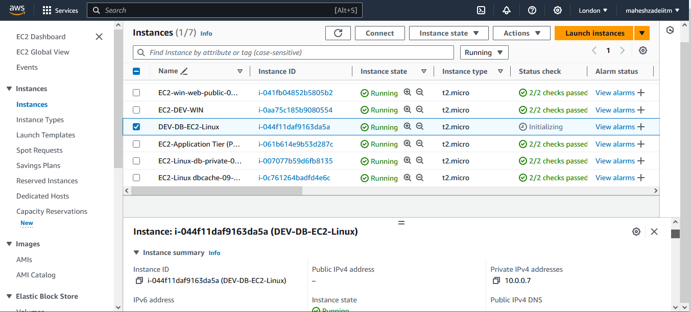

Copy private IP address of db EC2 Instacne and paste in web win Machine Mobaxterm to connect

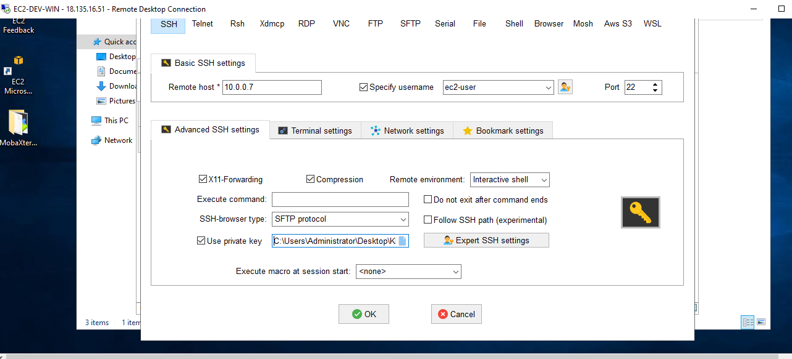

Now Click on OK  
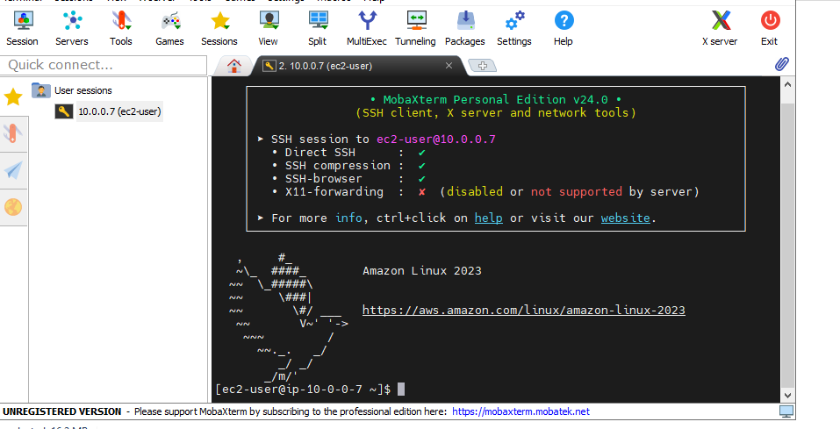

Create peering connection between production network and development

network.

Go to Peering connection

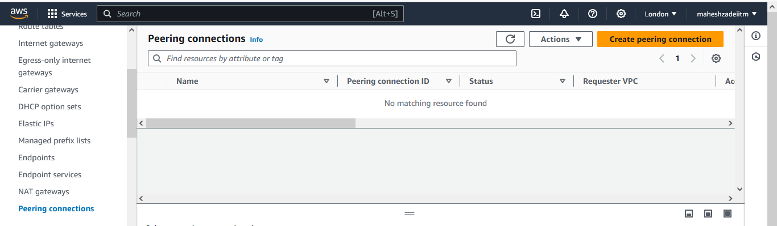

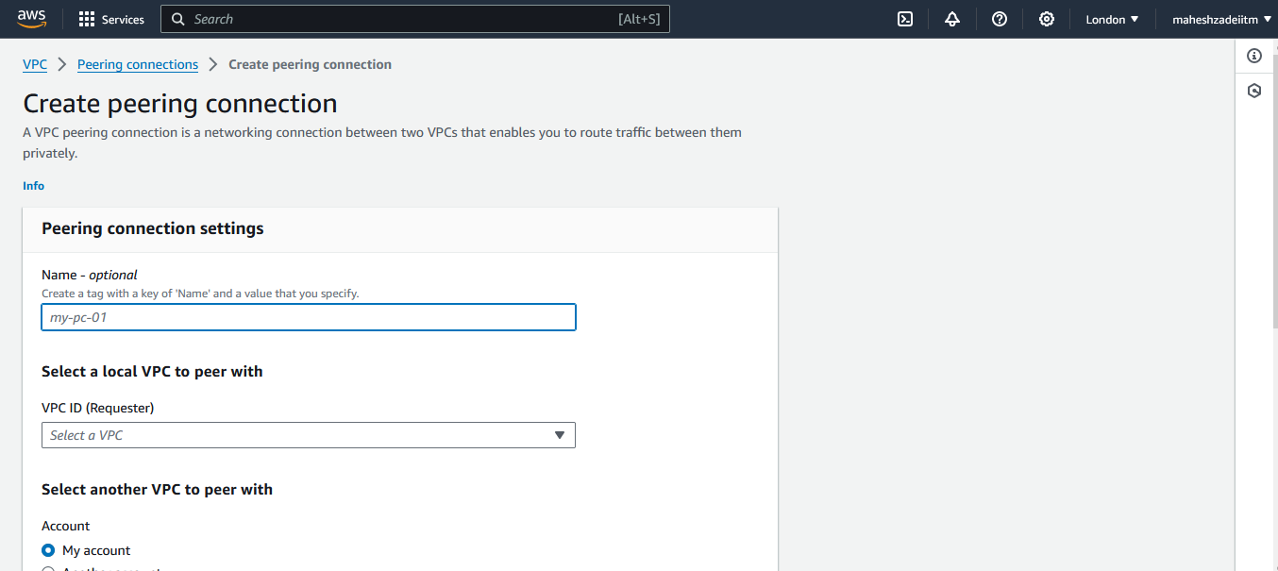

Give the name of Peering connection and select thr requester VPC I London Region

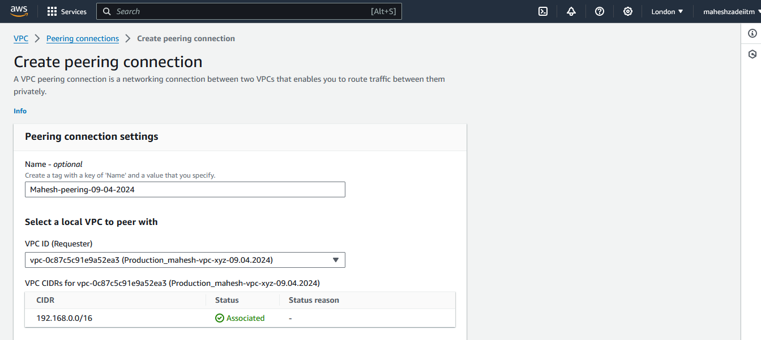

Select requester acceptor VPC

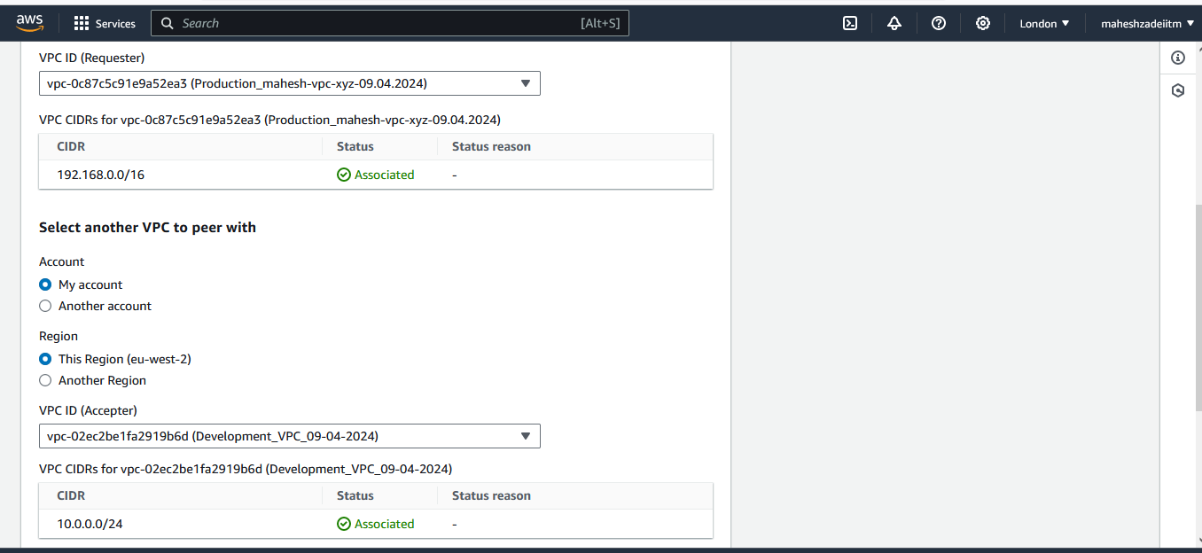

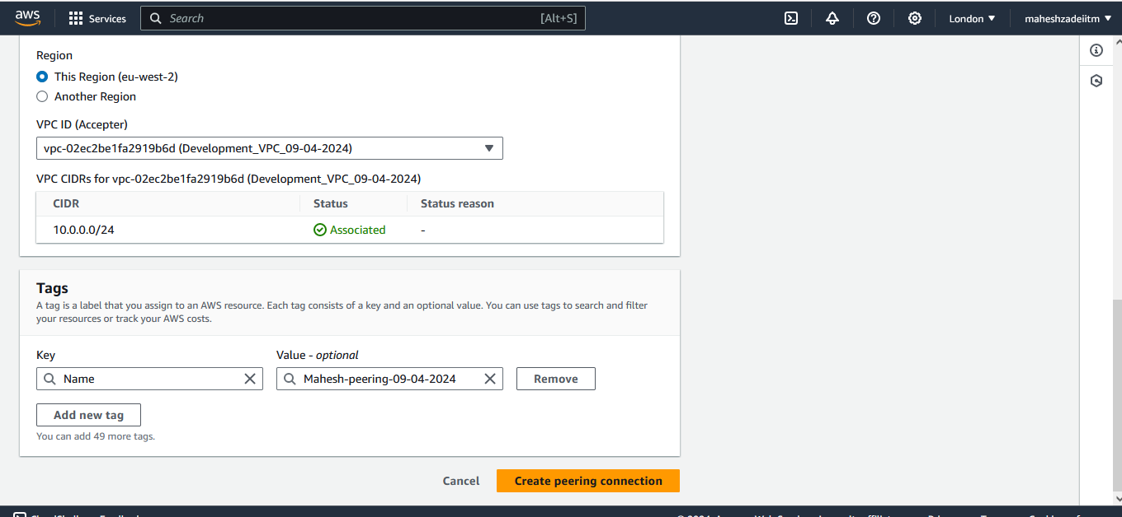

Click on create peering connection

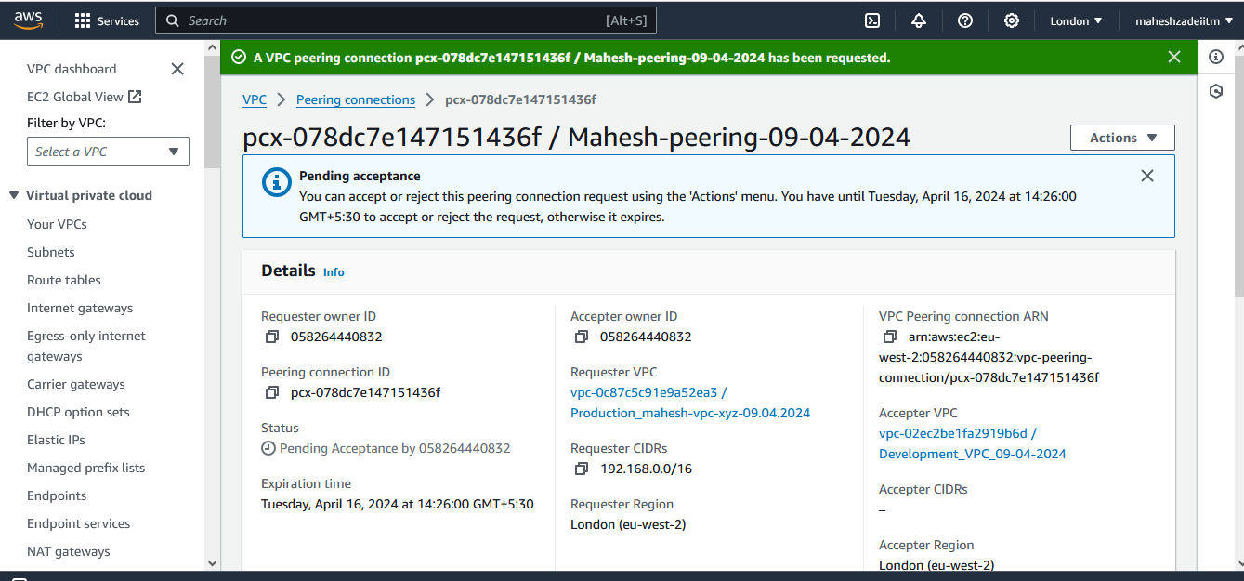

Showing pending acceptacne

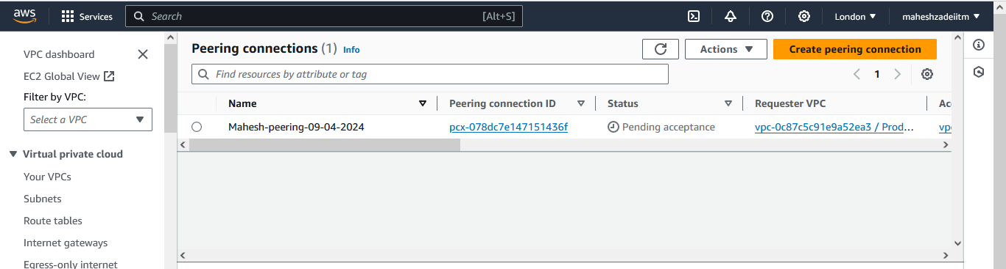

Click on access the request

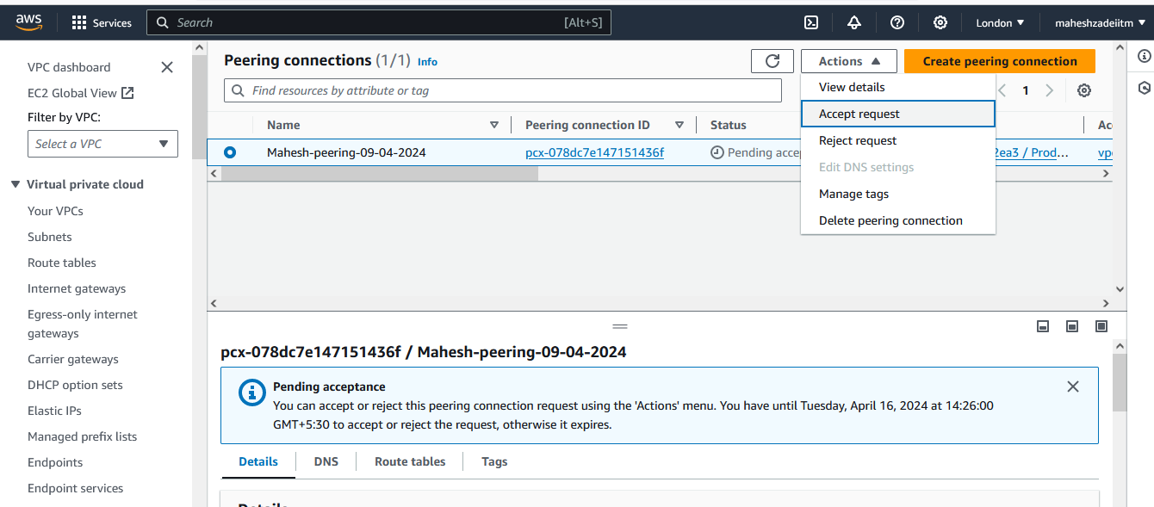

Access the VPC Peering request

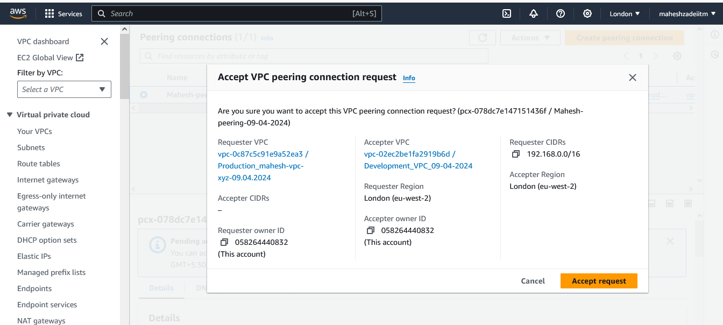

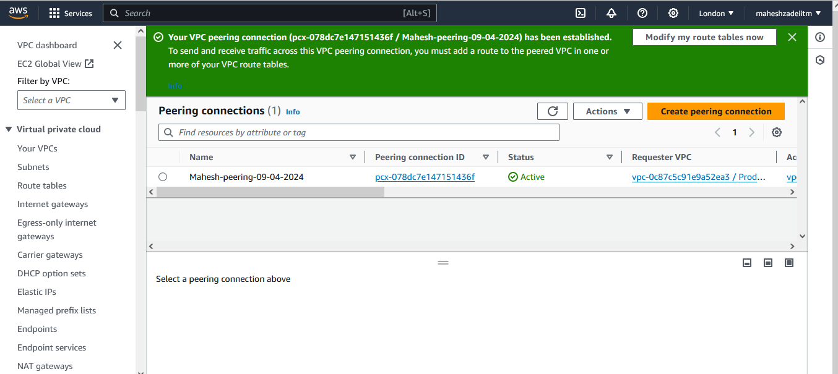

Now hsowing peering connection Active

Now check the connectivity between two VPC instances

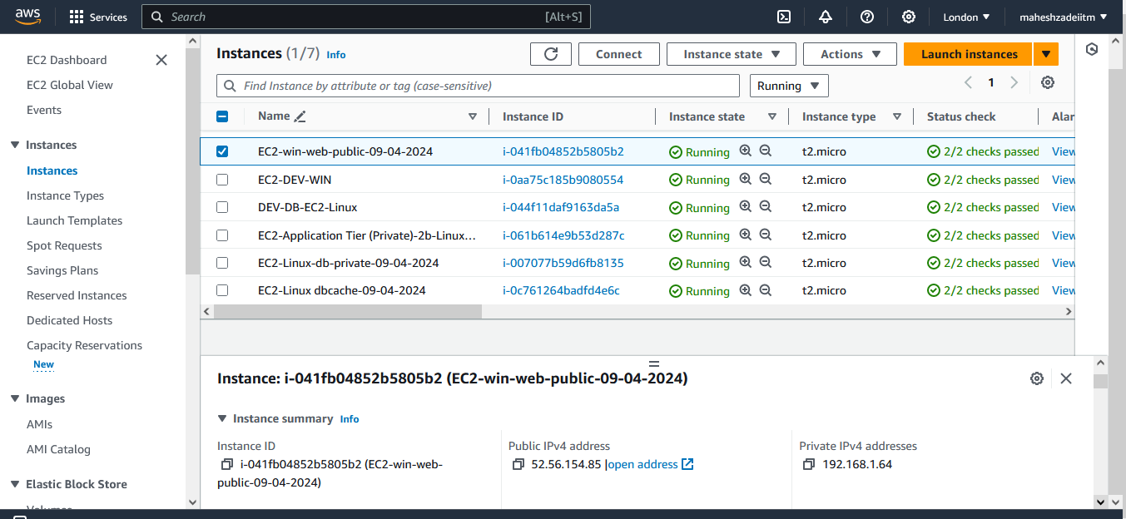

Copy Public IP of Production VPC EC2 Win Machine and try to connect the Linux EC2 from Developmnet VPC

Add ICMP protocol in both db SG of production and Development



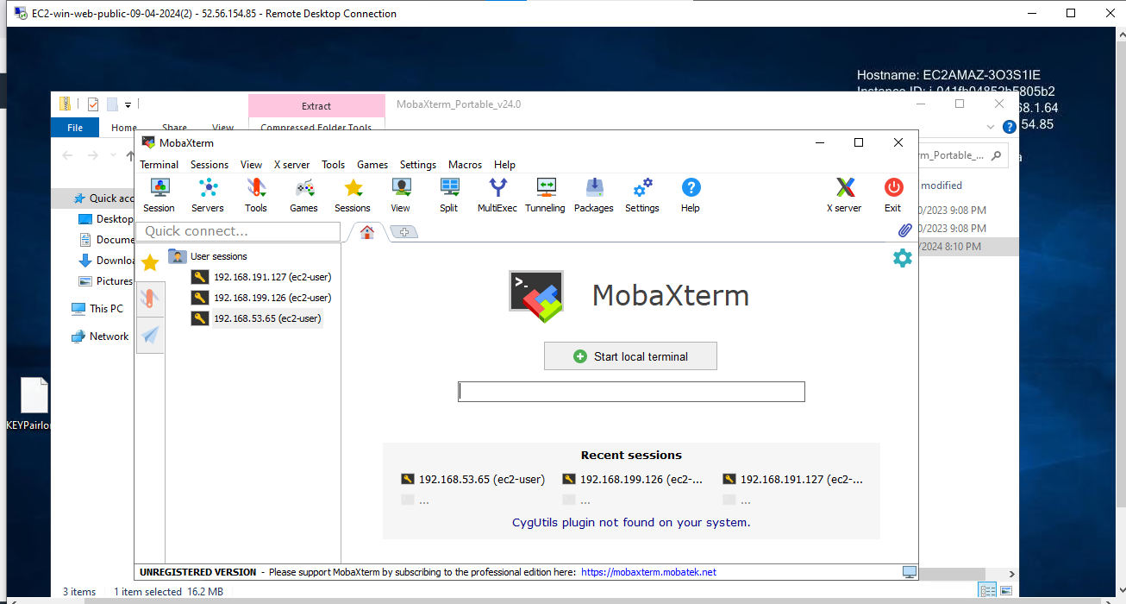

Copy Private IP from Development VPC EC2 Machine now .

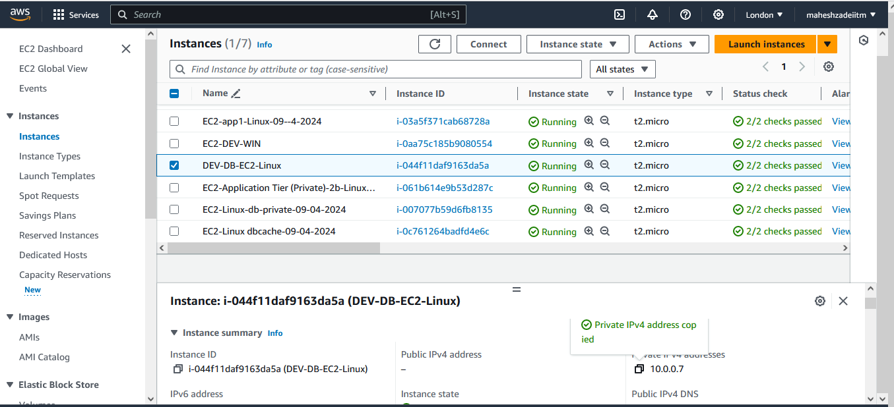

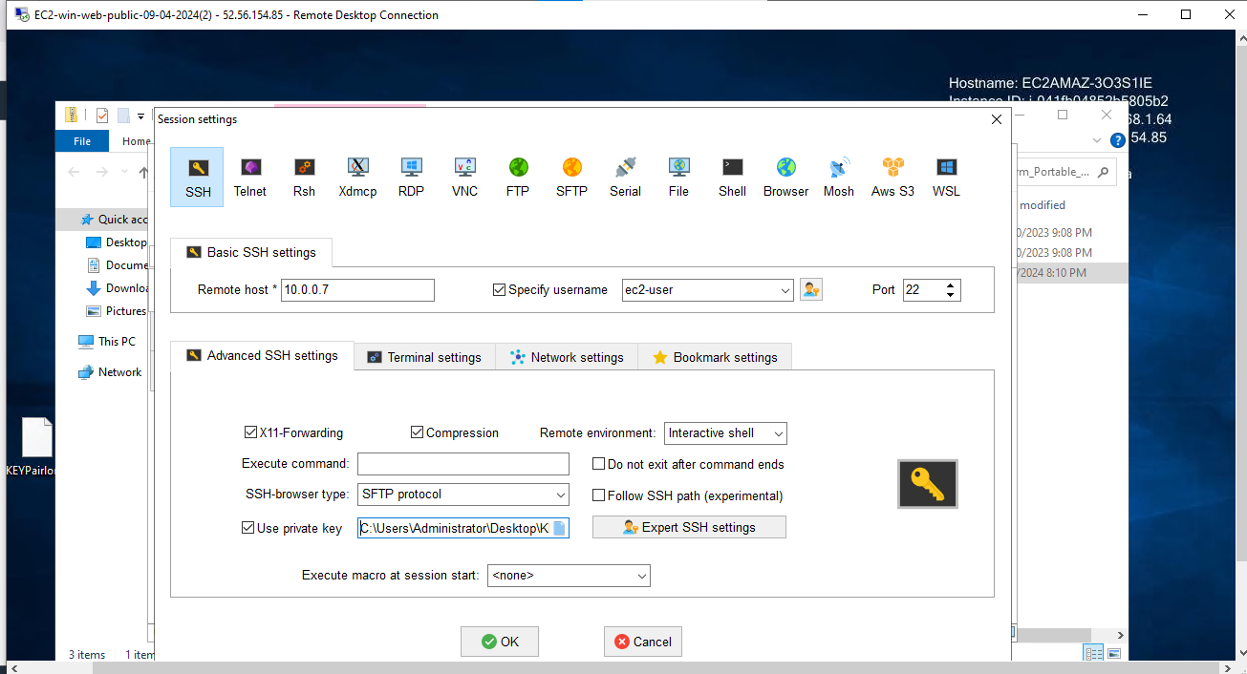

From Linux Machine we are able to connect from private subnet.

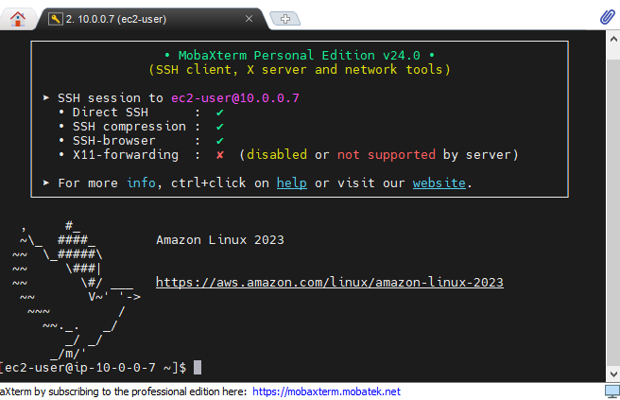

Thanks

LMS VPC Assignment completed

Pls check and update.